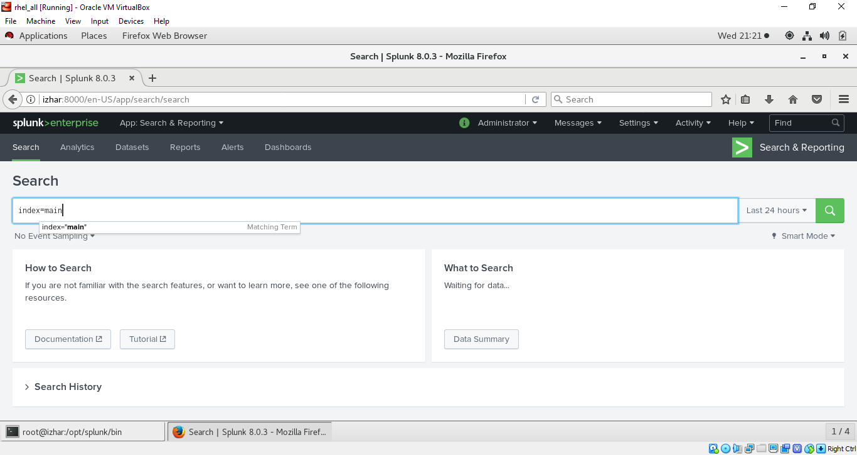

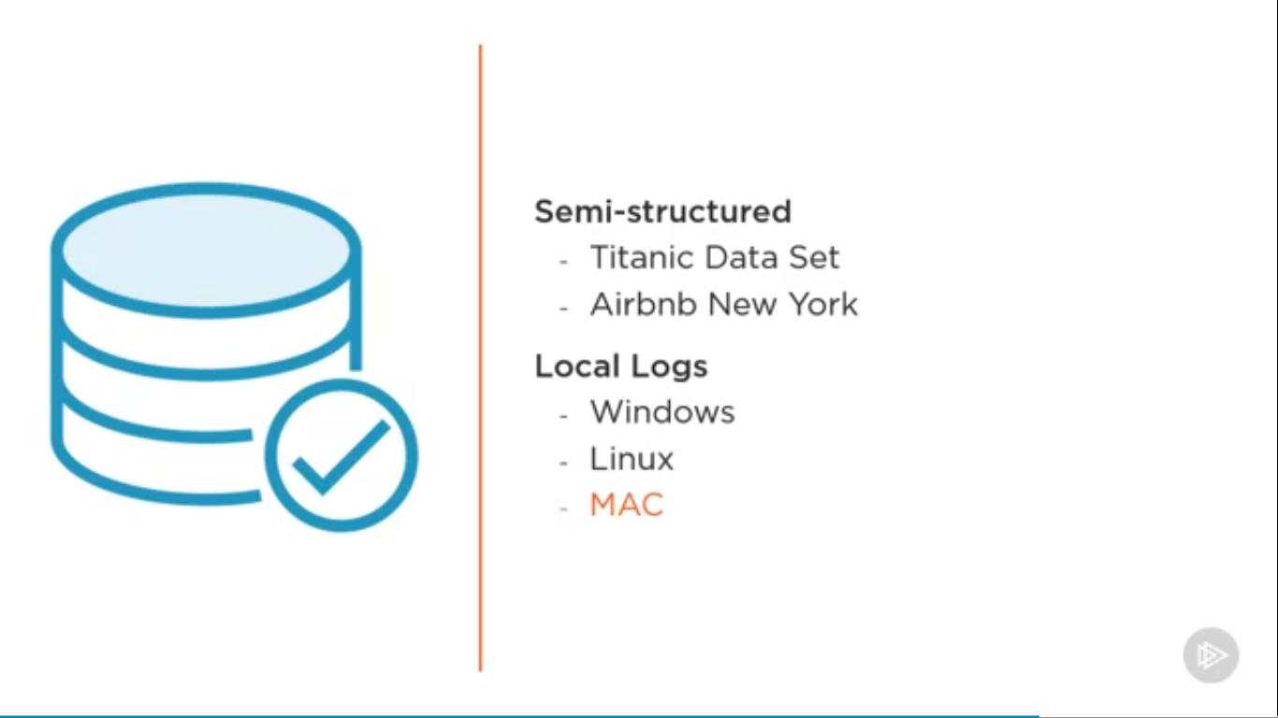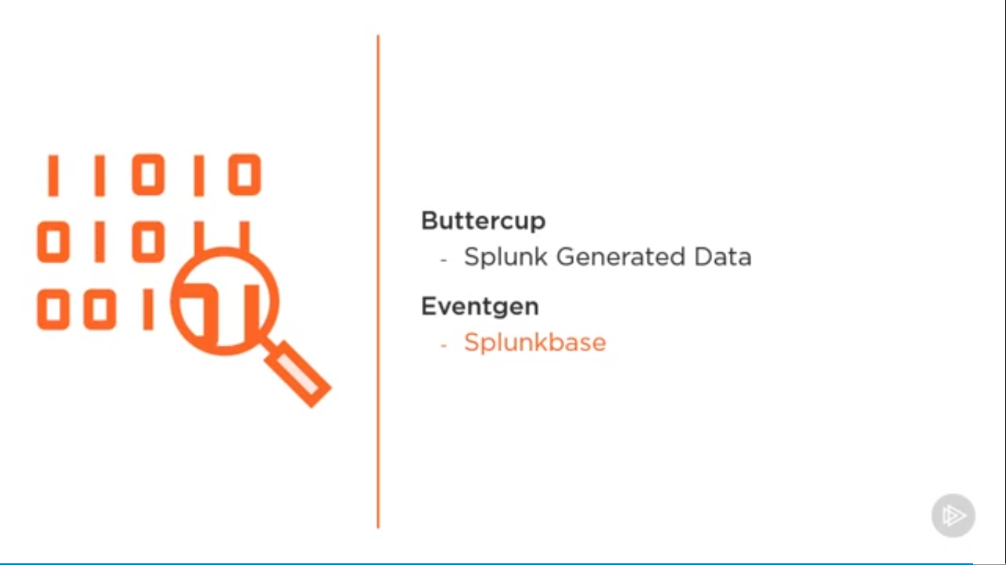

USING AIRBNB AND TITANIC DATASETS (AVAILABLE ON KAGGLE)

UPLOADING DATA

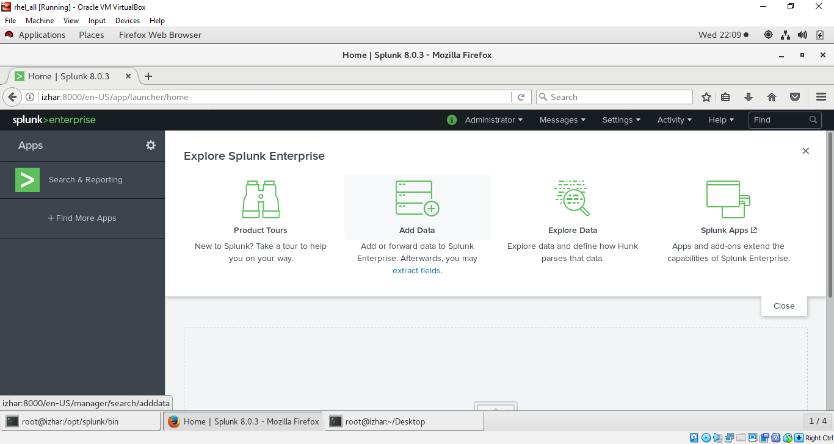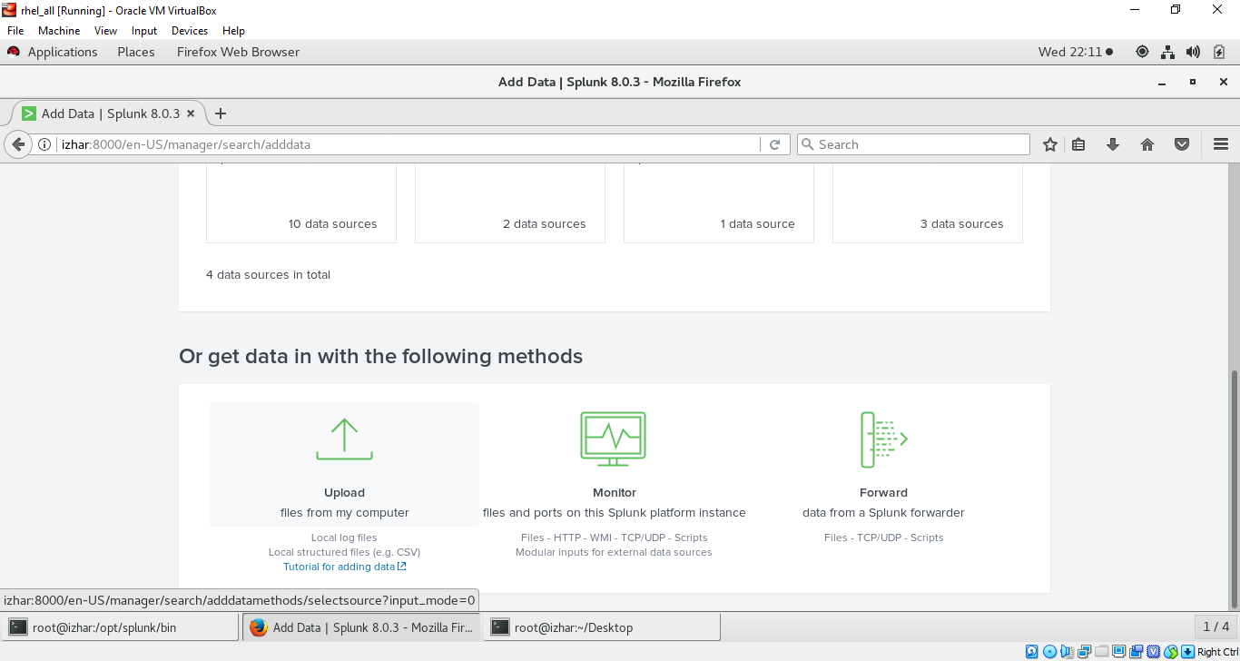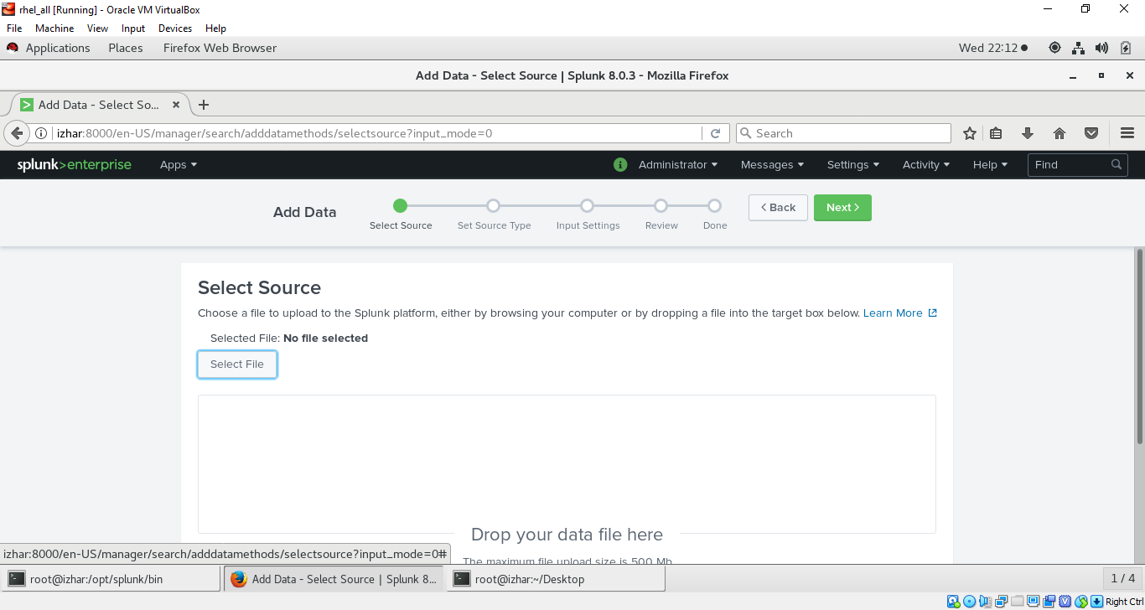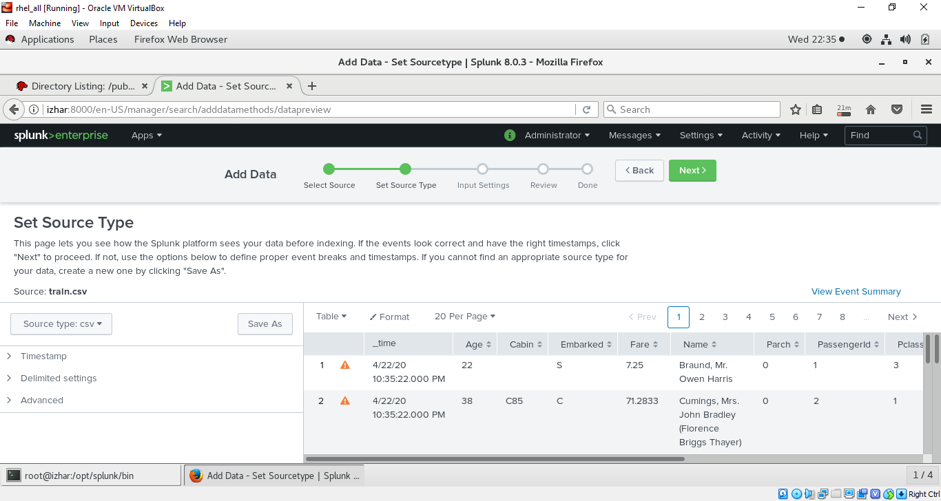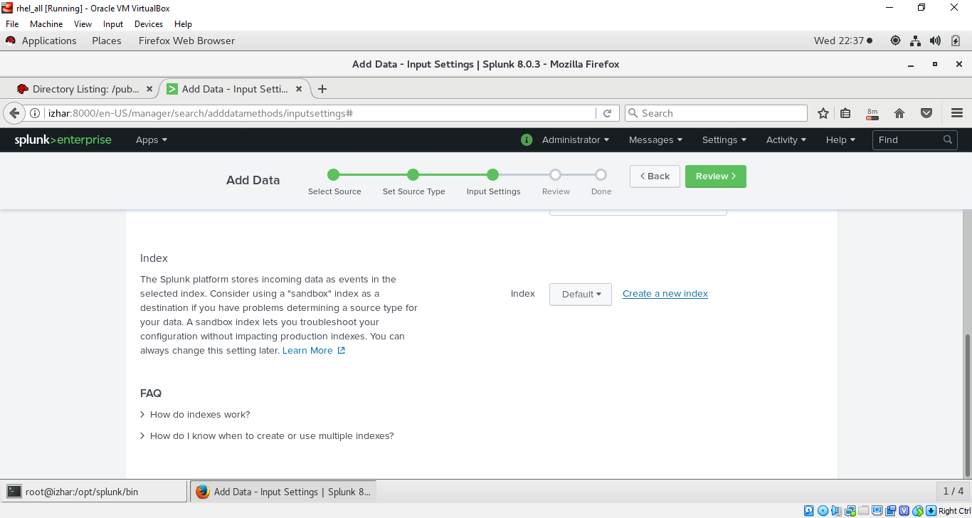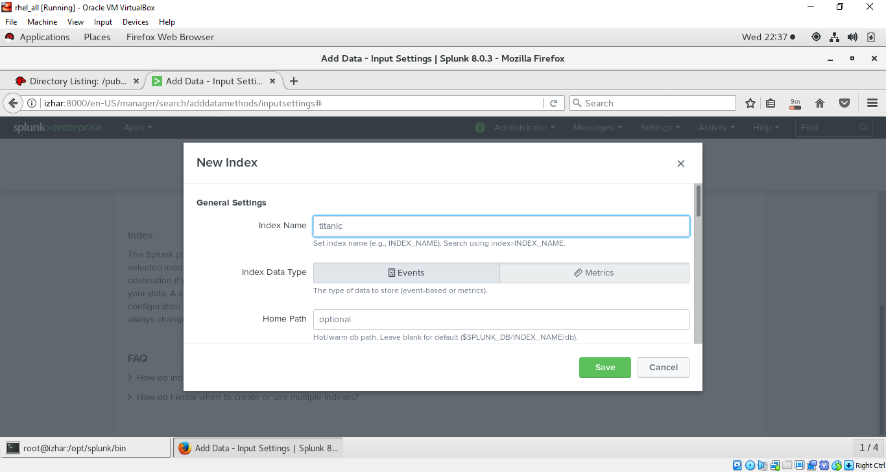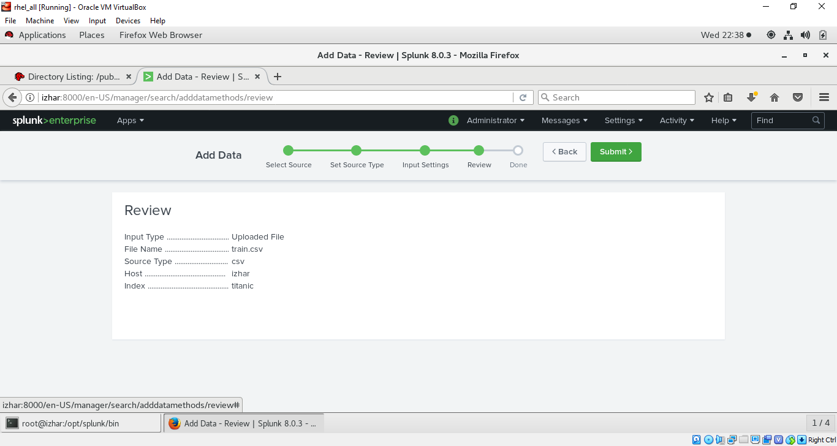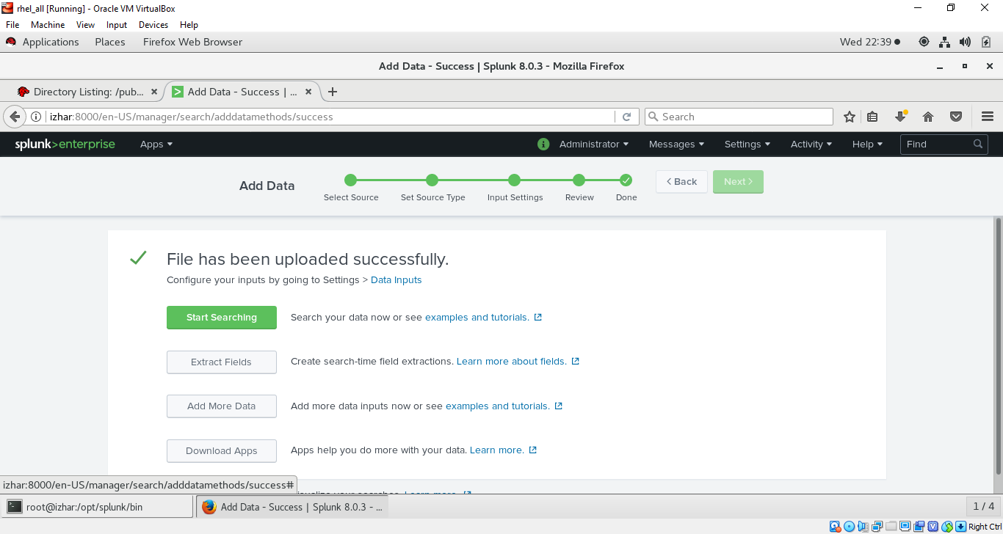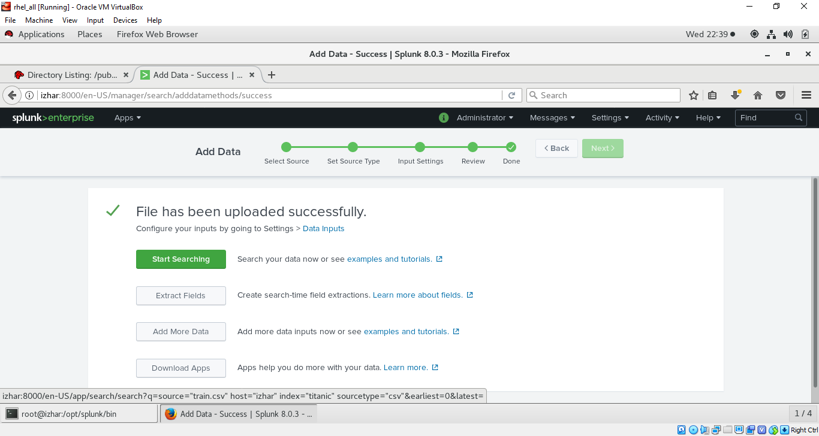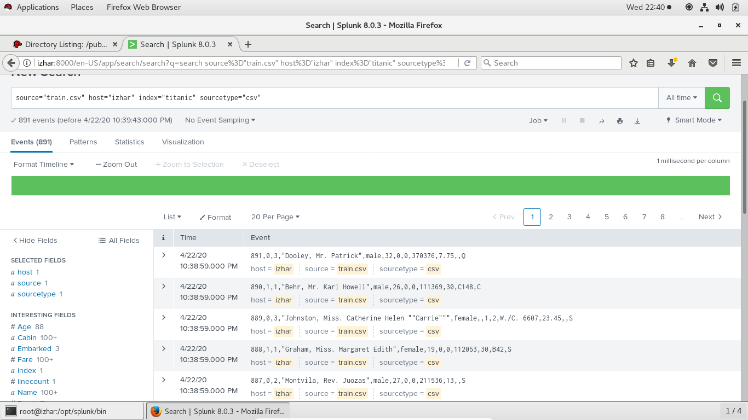

* DOING SAME WITH AIRBNB DATASET

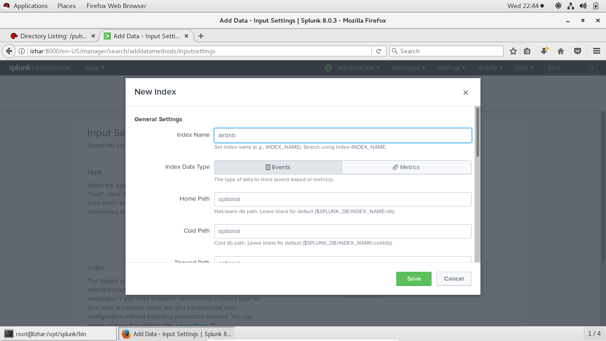

* IMPORTANT THINGS ABOUT SPLUNK INFRASTRUCTURE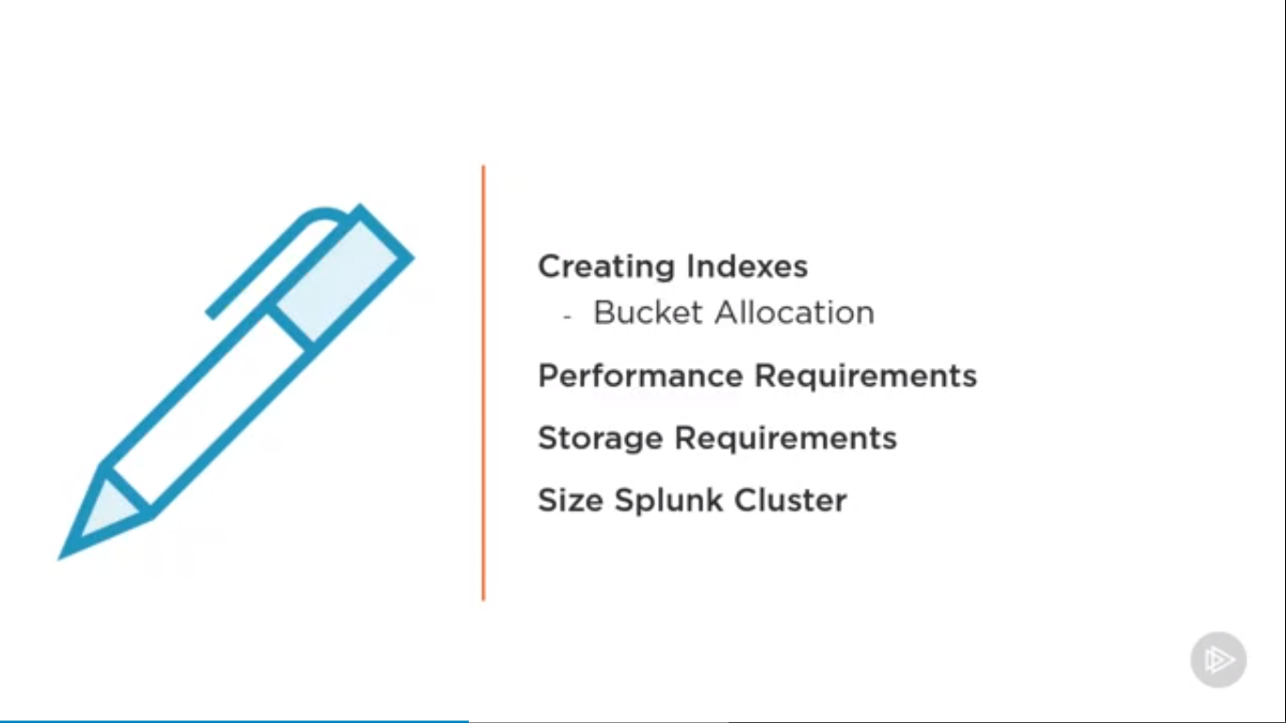
* SPLUNK BUCKET (EFFECT PERFORMANCE) 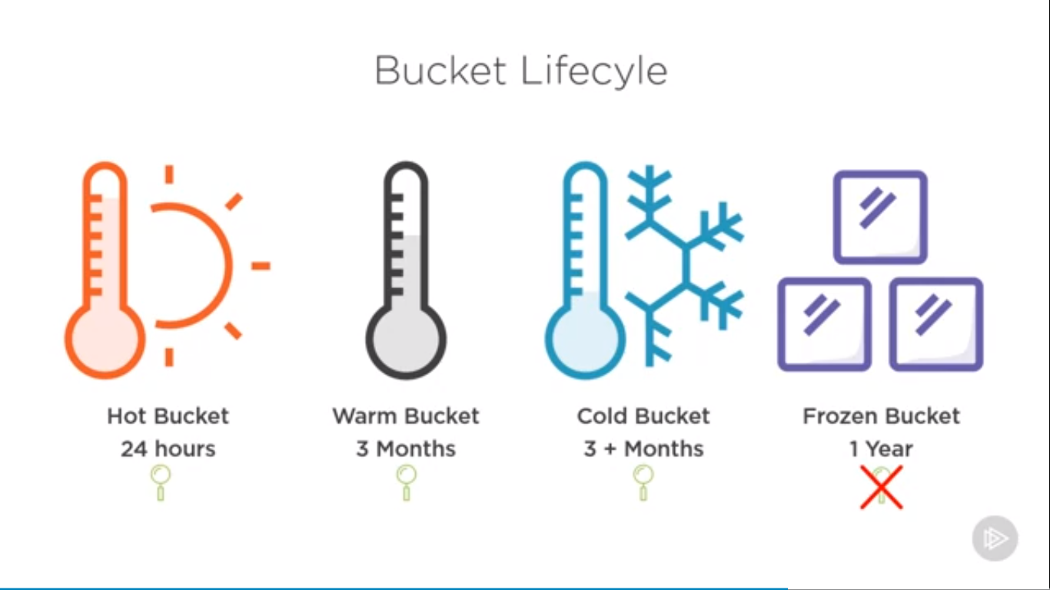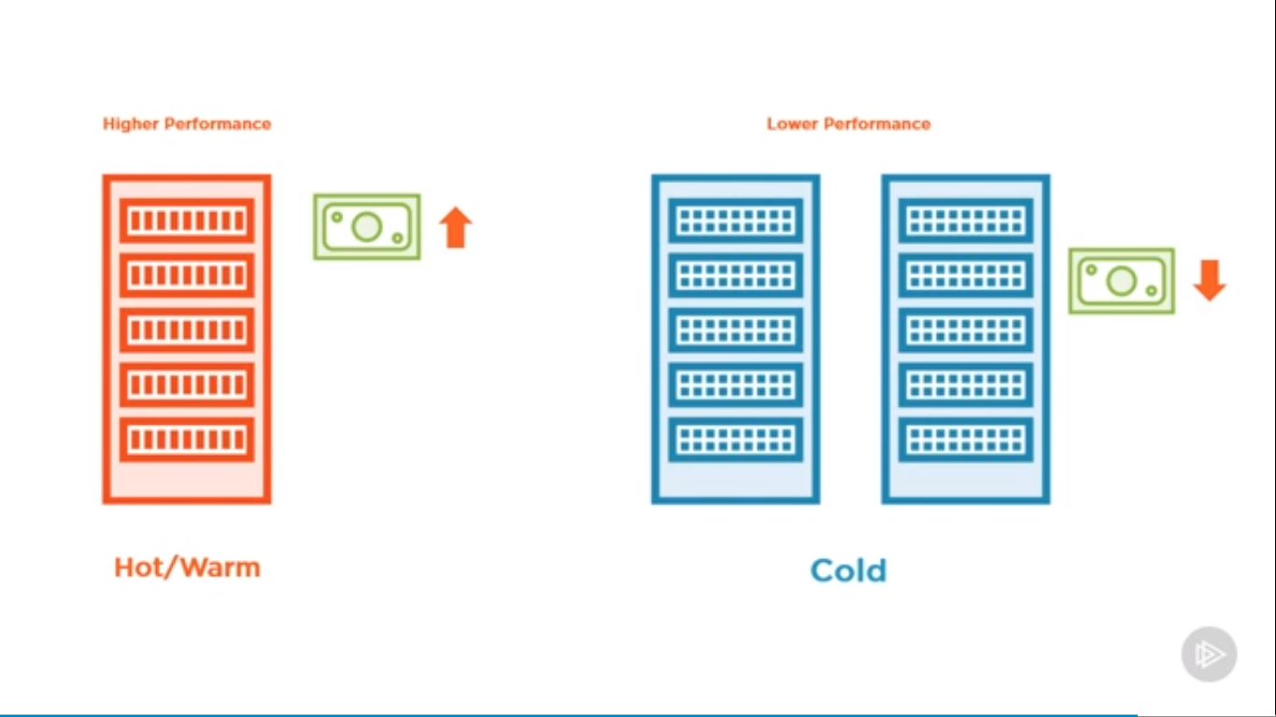
* BUCKET MANAGEMENT IN SPLUNK (GO TO SETTING SELECT INDEXES) 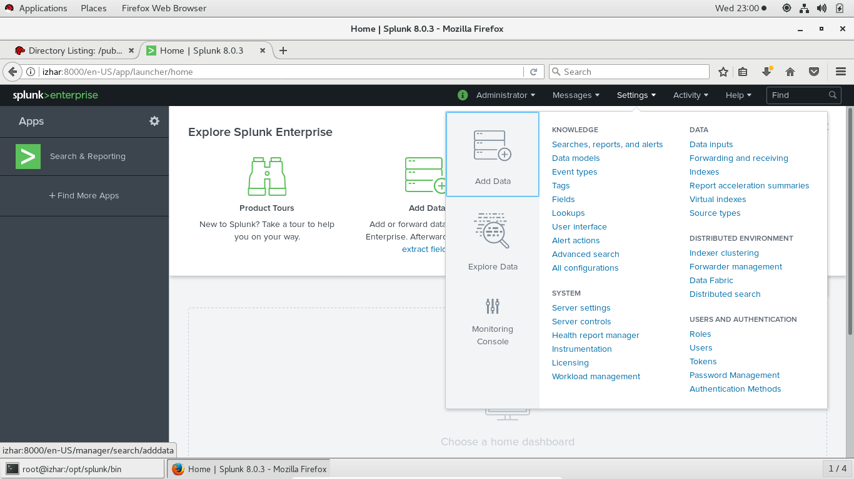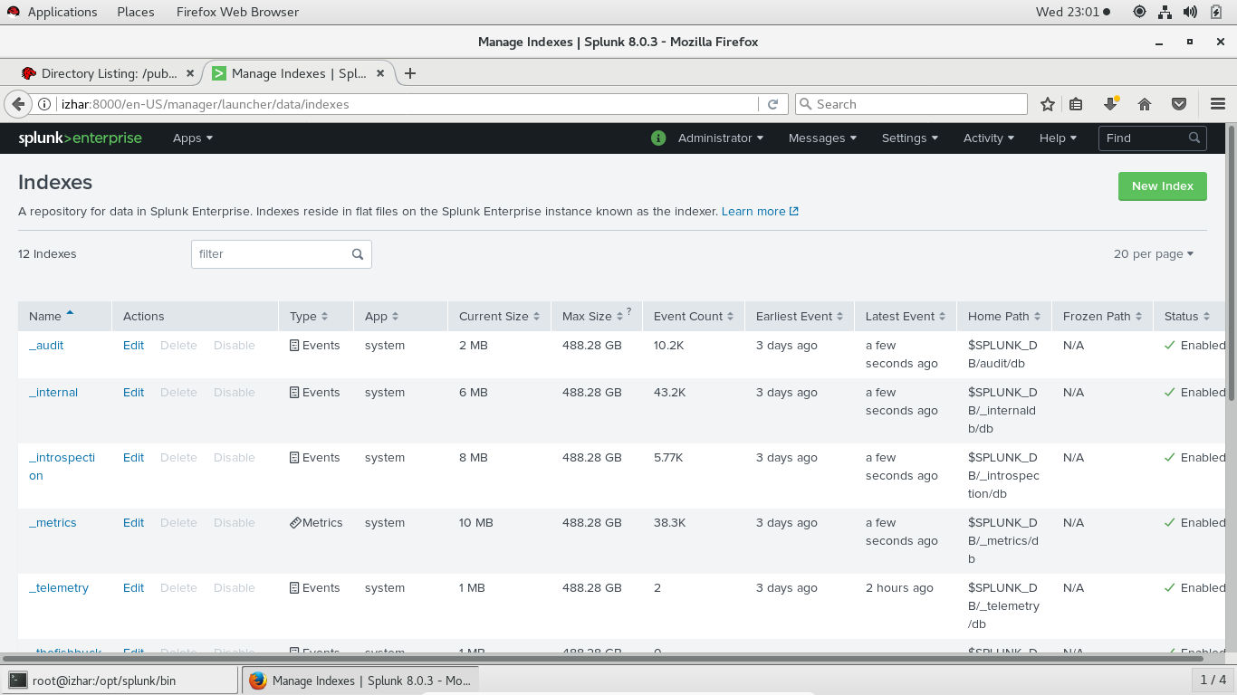
* CREATE NEW INDEX AND SET NAME TO ISLON_CLUSTER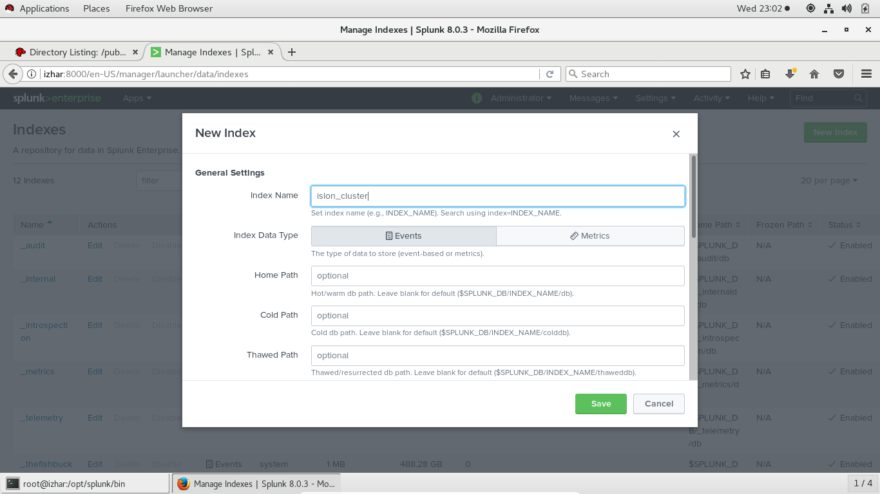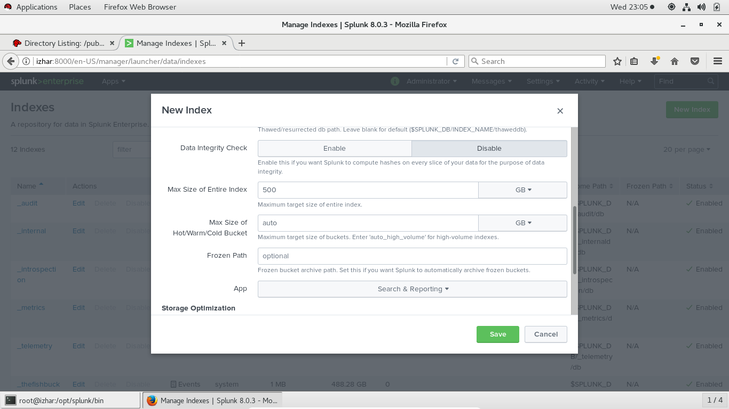
* SCROLL IT AND SEE MORE AFTER THAT CLOSE THIS INDEX OPTION
* NOW GOT TO AIRBNB DATASET CLICK ON EDIT 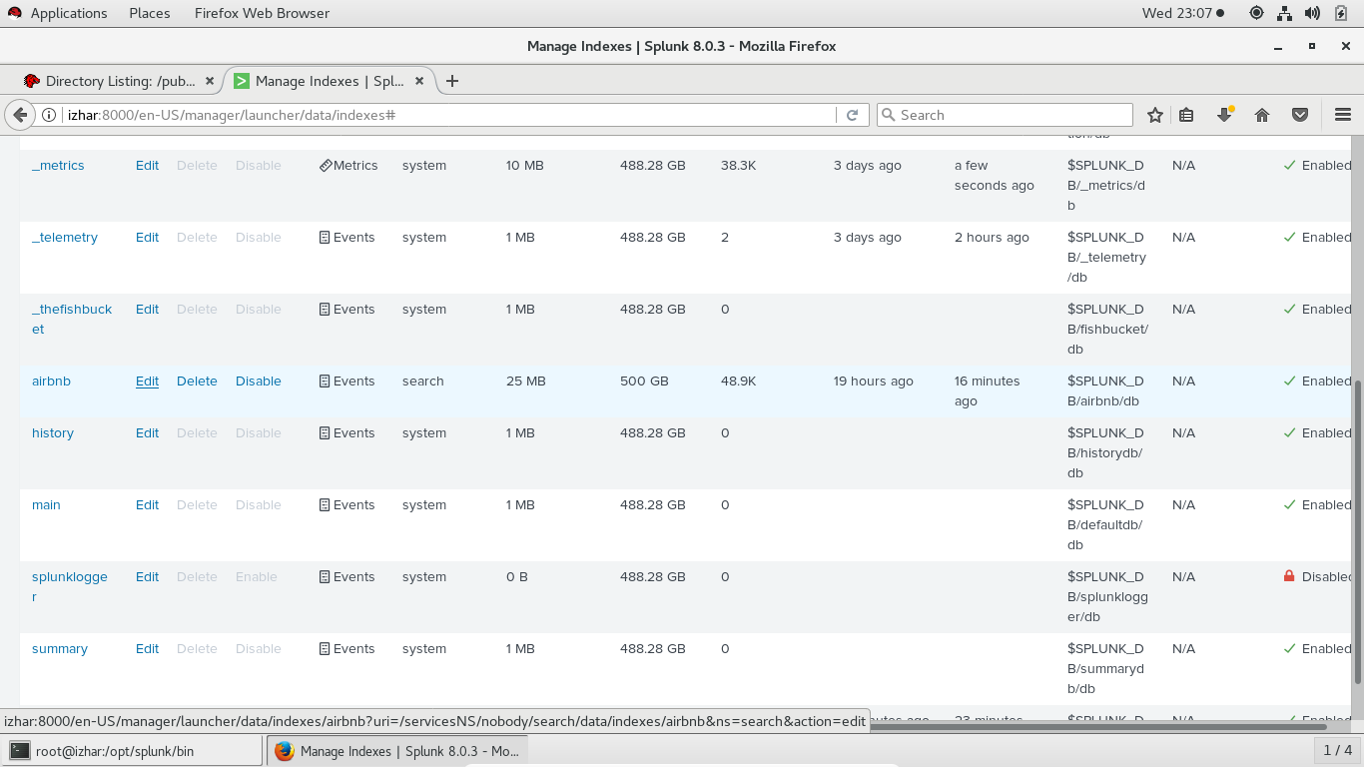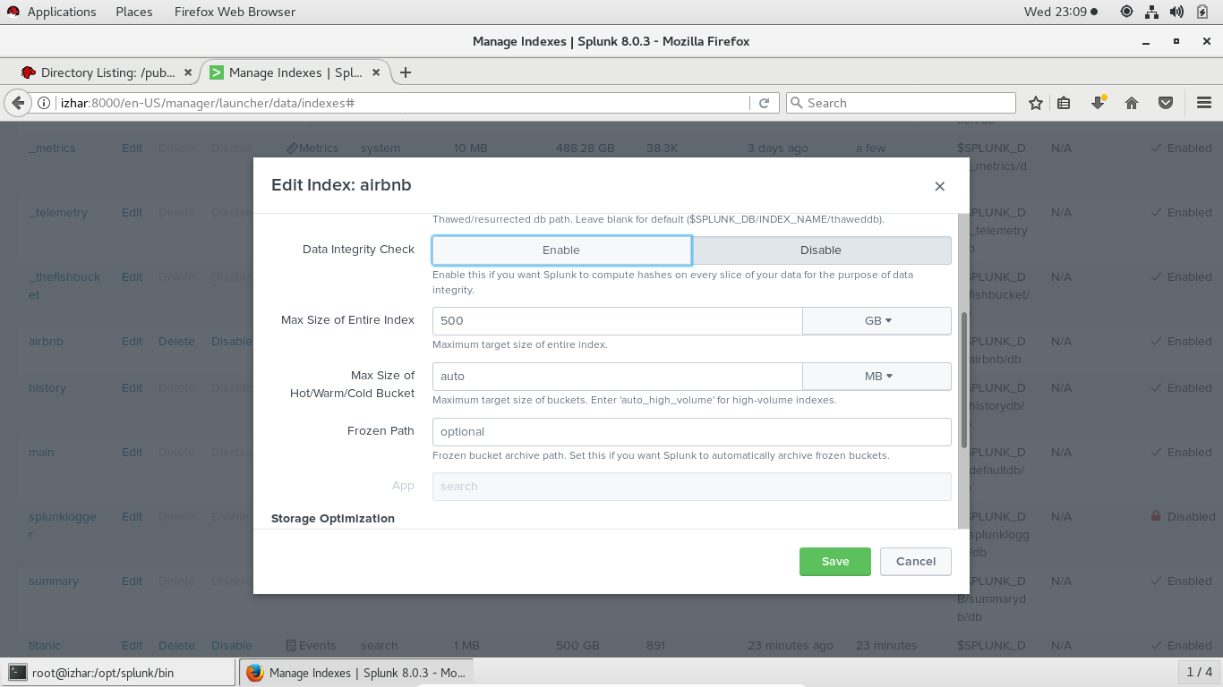
* IN THE ABOVE SCREEN YOU WILL SEE THE BUCKET OPTION IN THIS WAY YOU CAN MANAGE BUCKET IN SPLUNK
* IMPLEMENTING SEARCHES (GO TO SEARCH BAR CHANGE SIDE SEARCH OPTION TO ALL TIME AND SEARCH INDEX AIRBNB AS :- 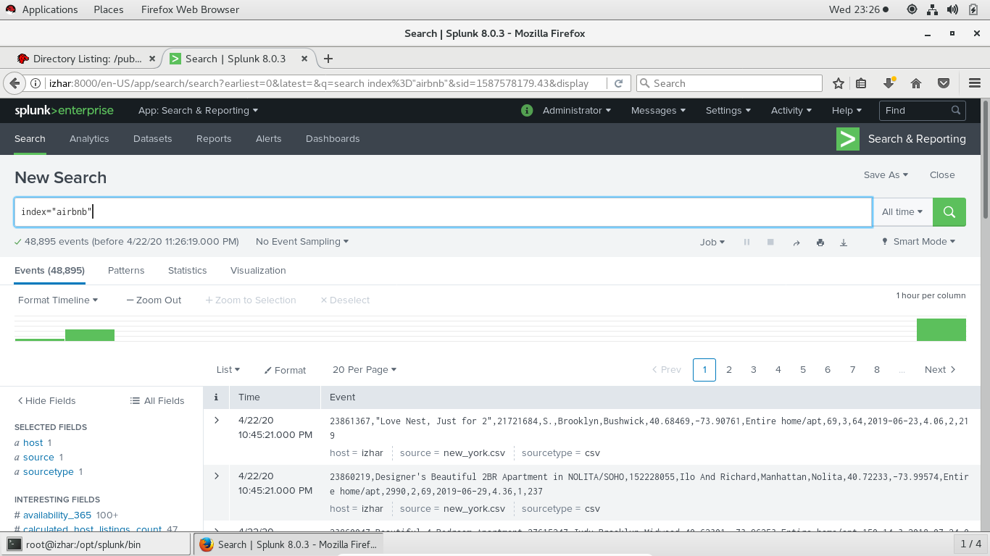
* SEARCH FOR ROOM TYPE (NOTE:- FIELDS ARE CASE SENSITIVE)

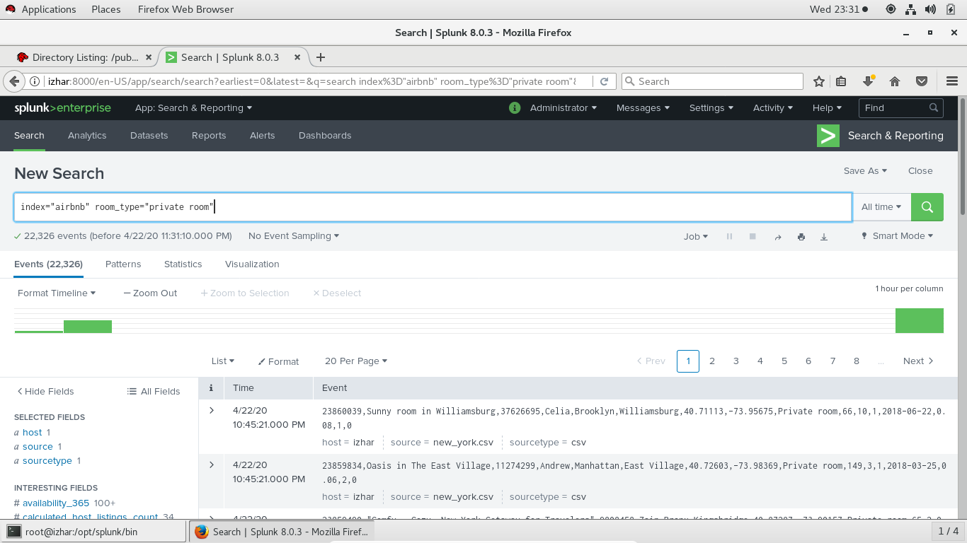

* NOW USING != in place of = IN FIELD SEARCH

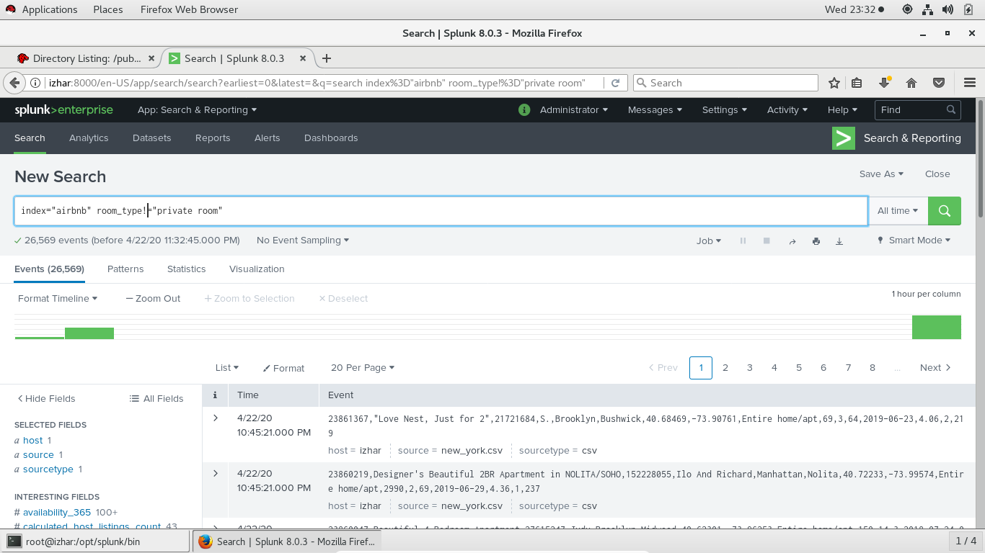

* USING BOOLEAN ALONG WITH IT AS:- 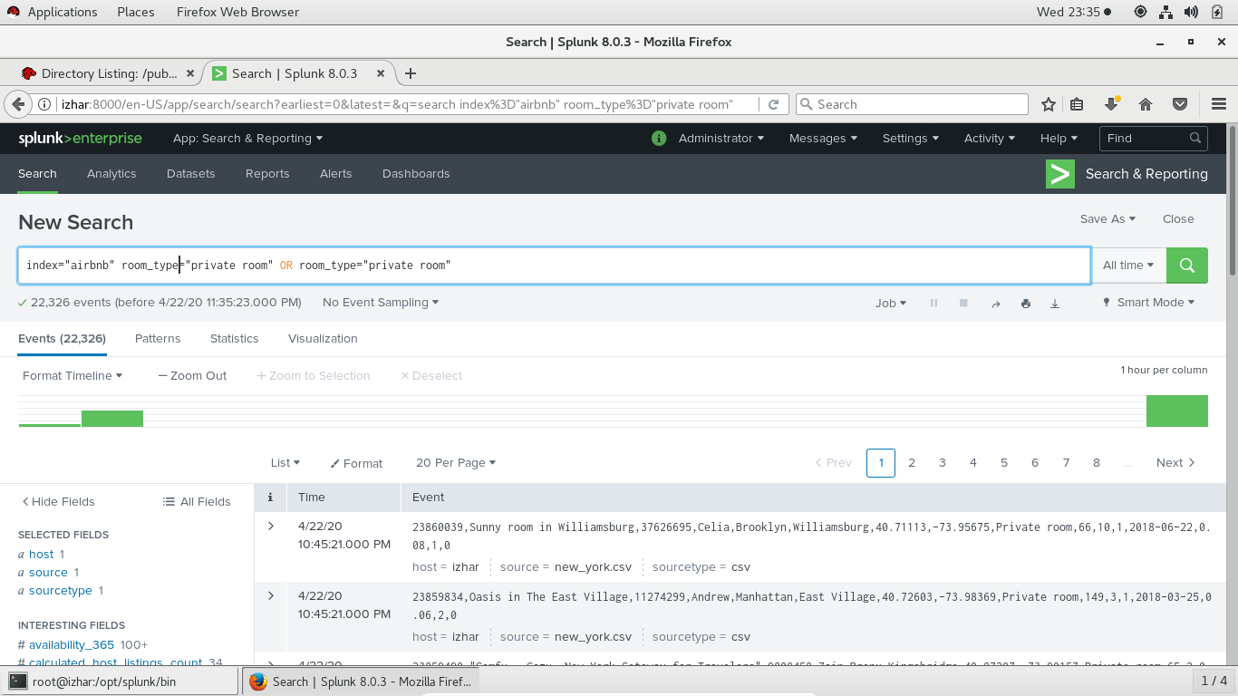
* VALUES ARE NOT CASE SENSITIVE AS DEMO :- 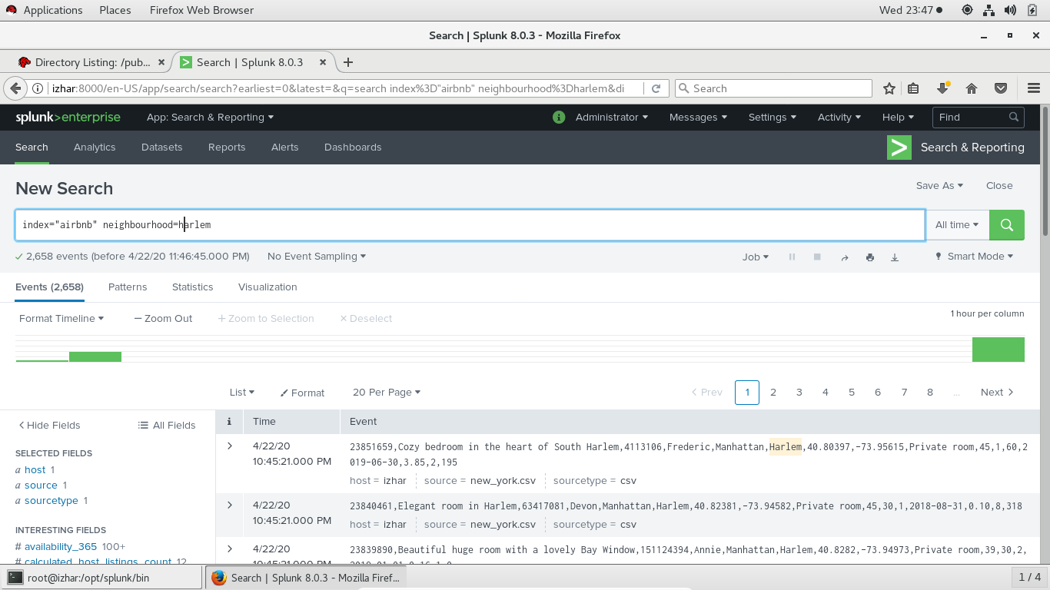
* WILDCARD DEMO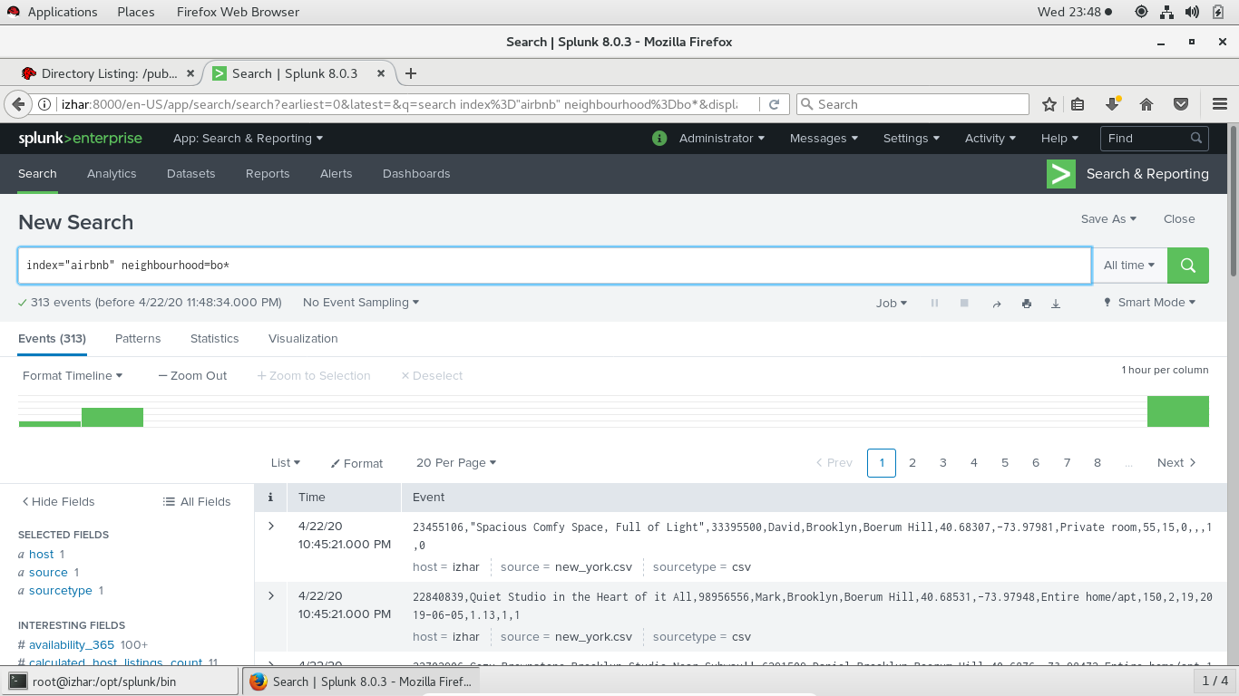
* CHOOSING SIDEBAR FIELDS DEMO (CLICK ON SIDEBAR FIELDS A SCREEN WILL POP UP CLICK ON YES TO SELECT):- 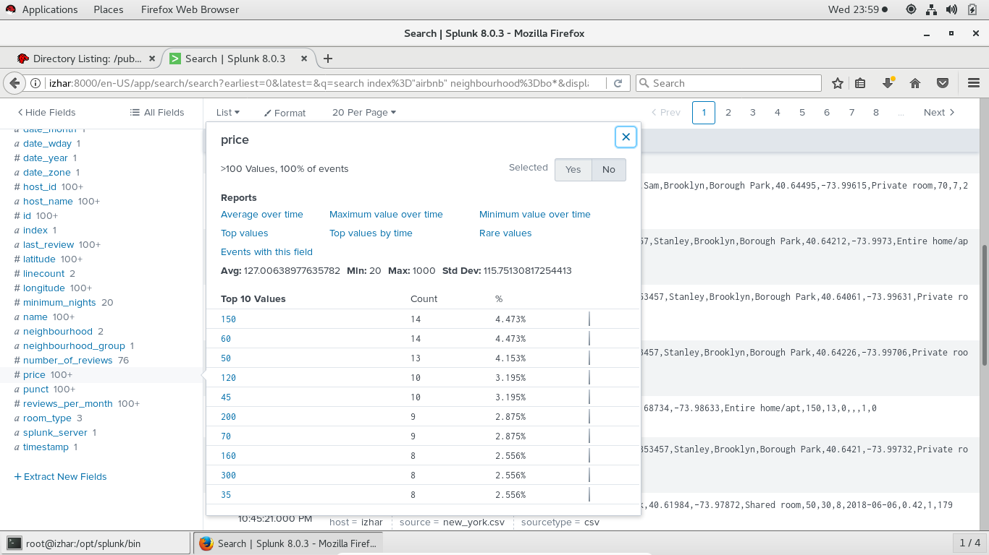
* AFTER THAT CLICK ON RARE VALUES (VISUALIZATION WILL APPEAR AND CUSTOMIZE CHART ACCORDING TO YOUR NEED) 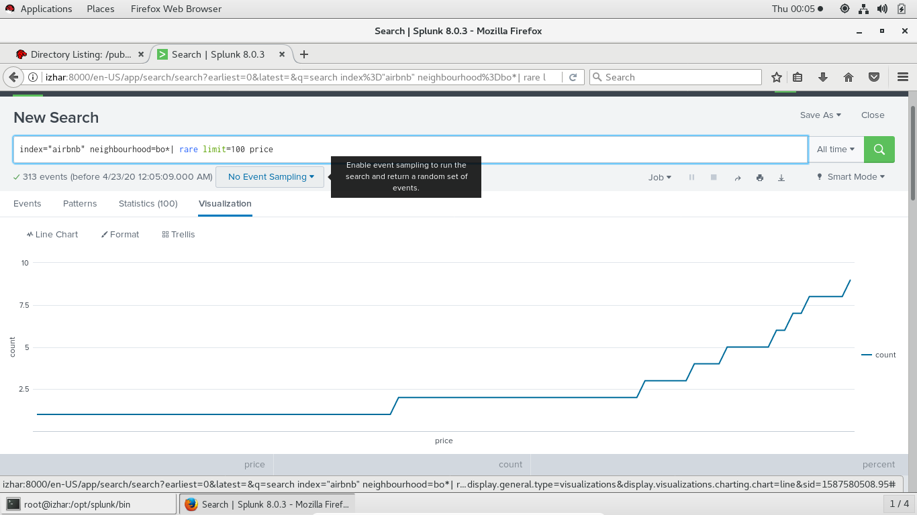
* CLICK ON LIST VIEW OPTION AND CHOOSE RAW VIEW :- 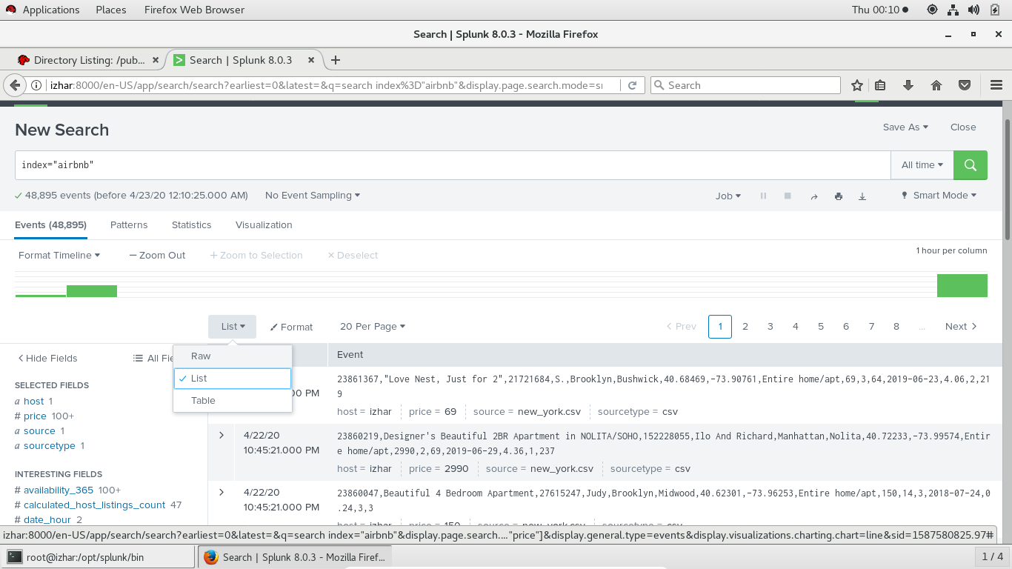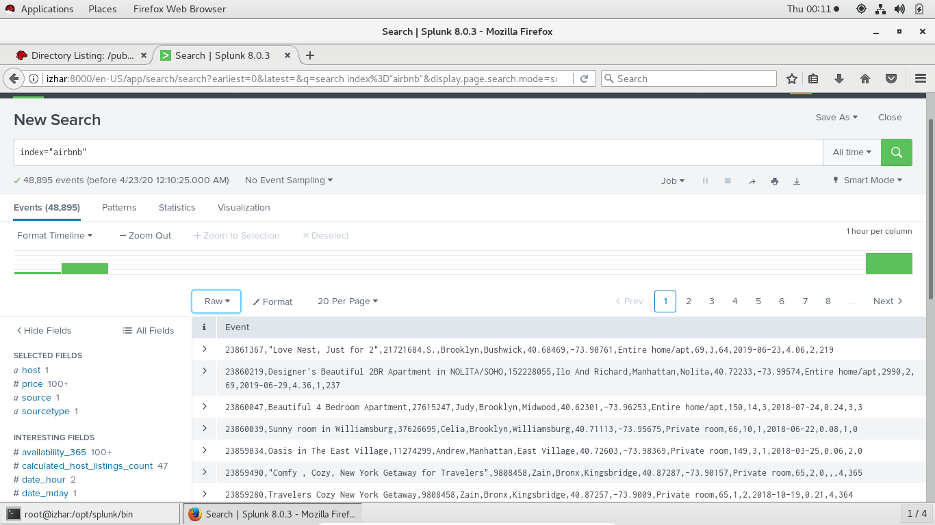
* SIMILARY WE CAN CHOOSE TABLE VIEW
* MORE SEARCHES :-

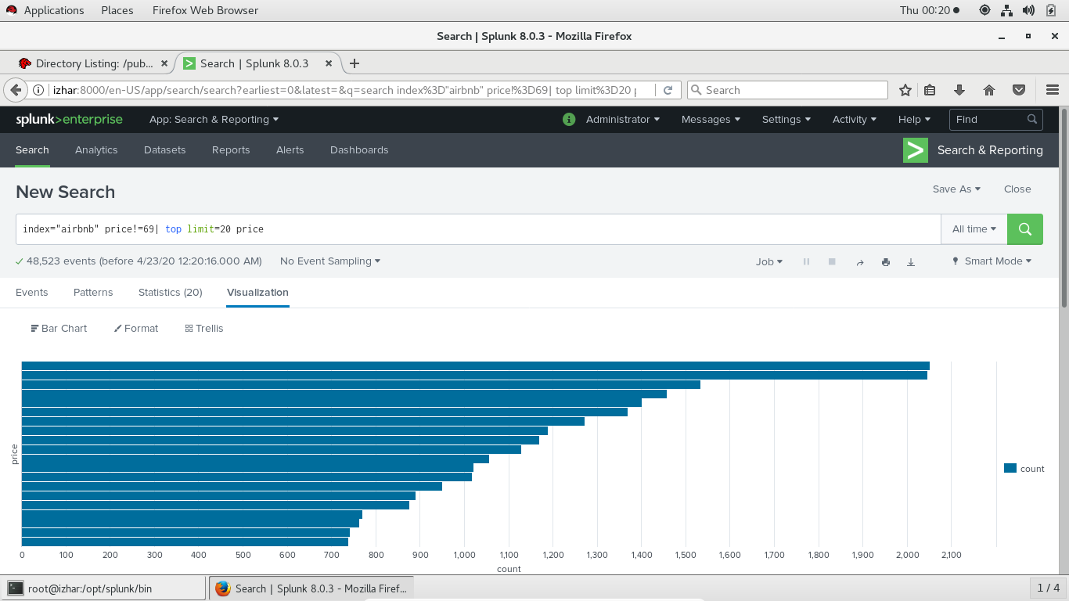

* WATCHING STATISTICS :- 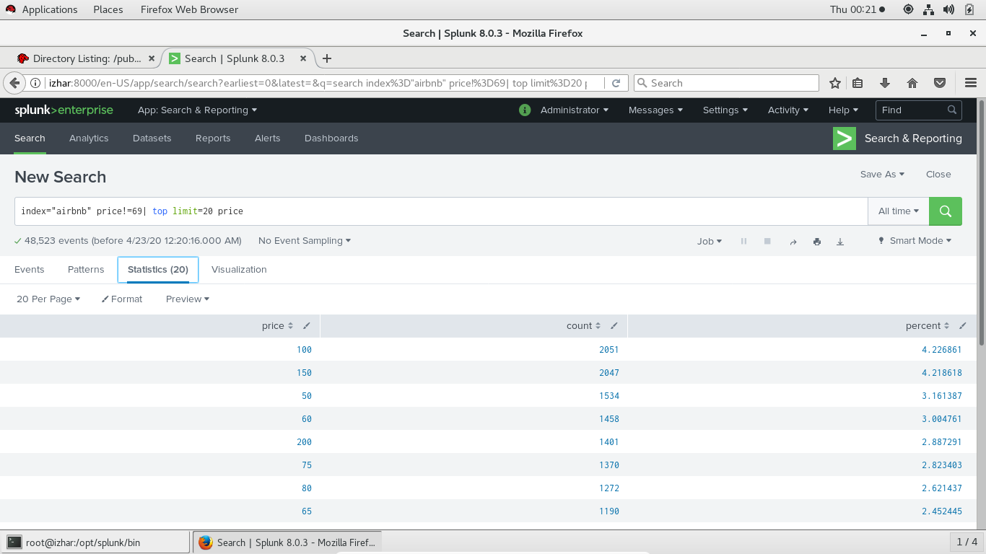
* SWITCHING PATTERN AND VERBOSE MODE :- 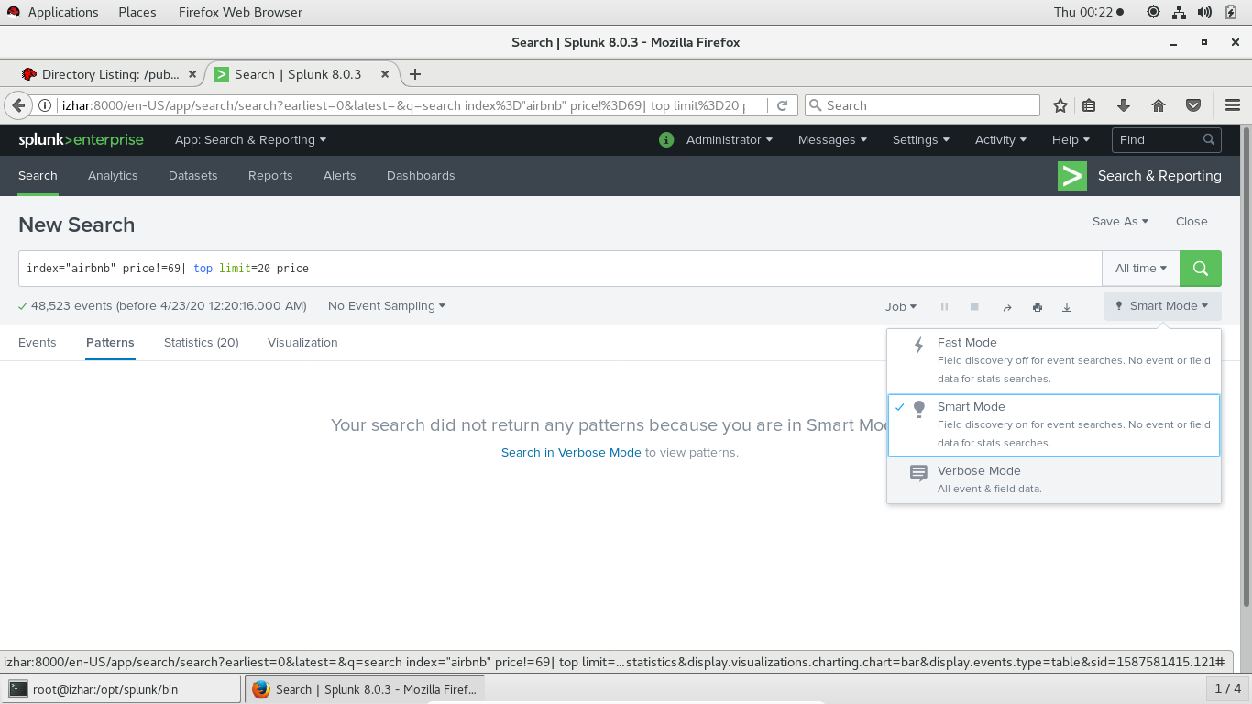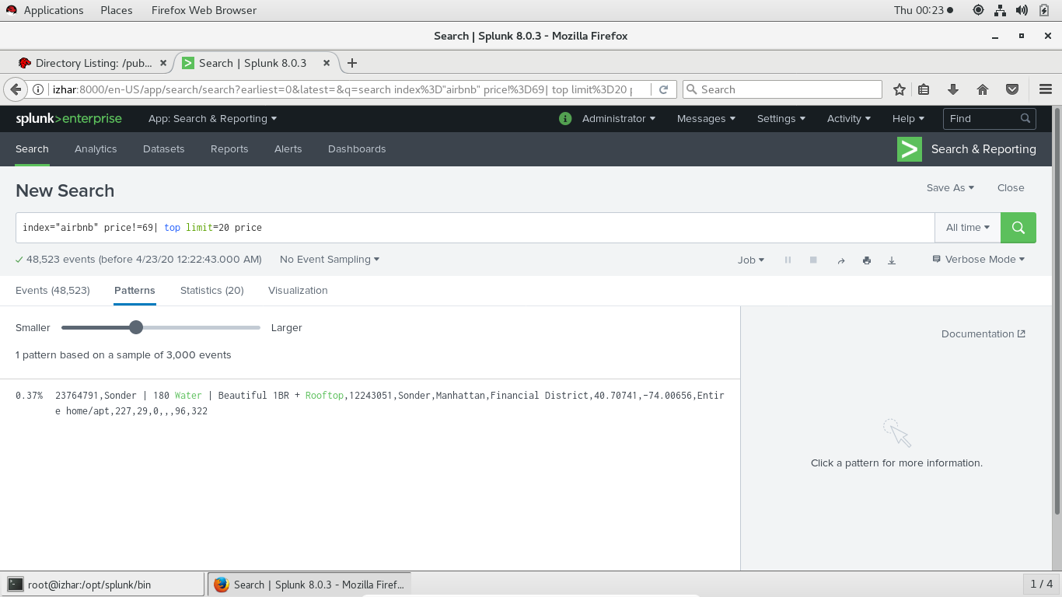
* SPL QUERIES :- 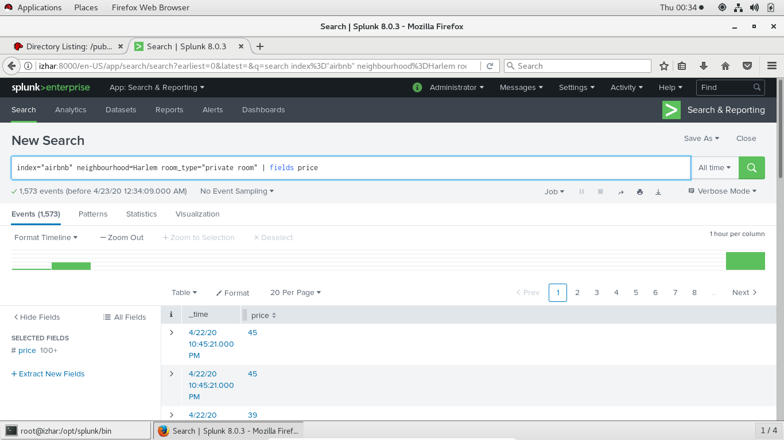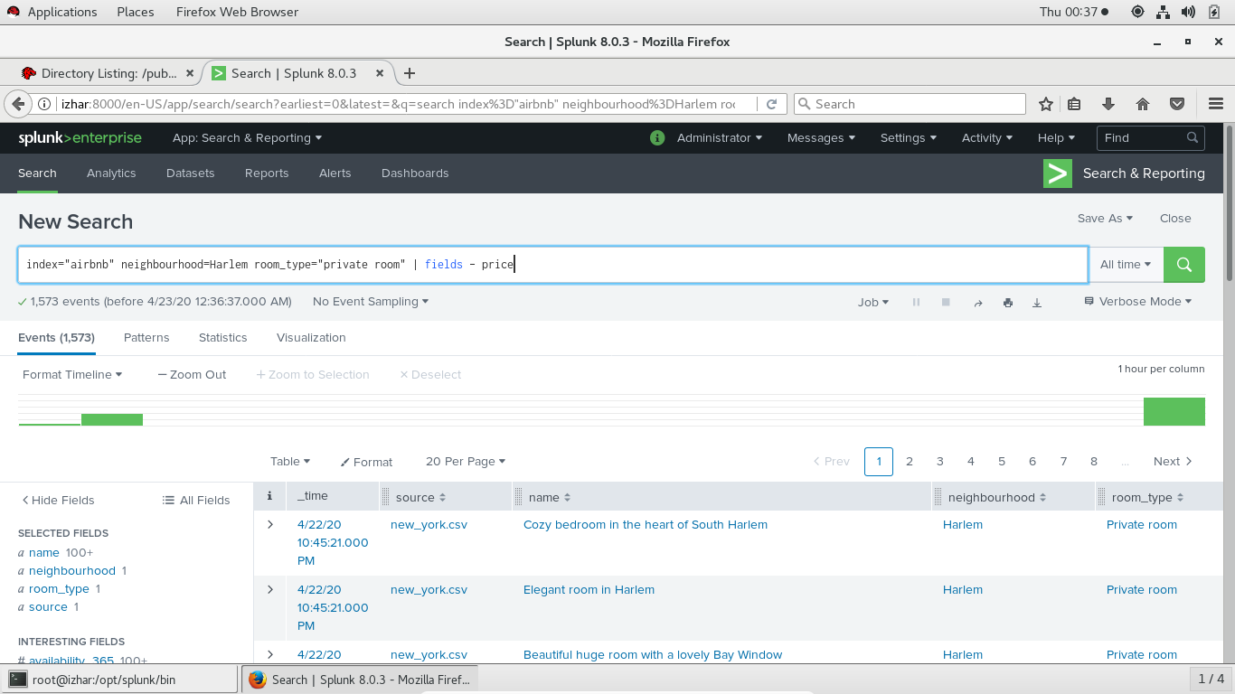
* CHANGING THEME OF SEARCH BAR (GO TO ADMINISTRATOR -> PREFERENCES -> SPL EDITOR -> THEMES 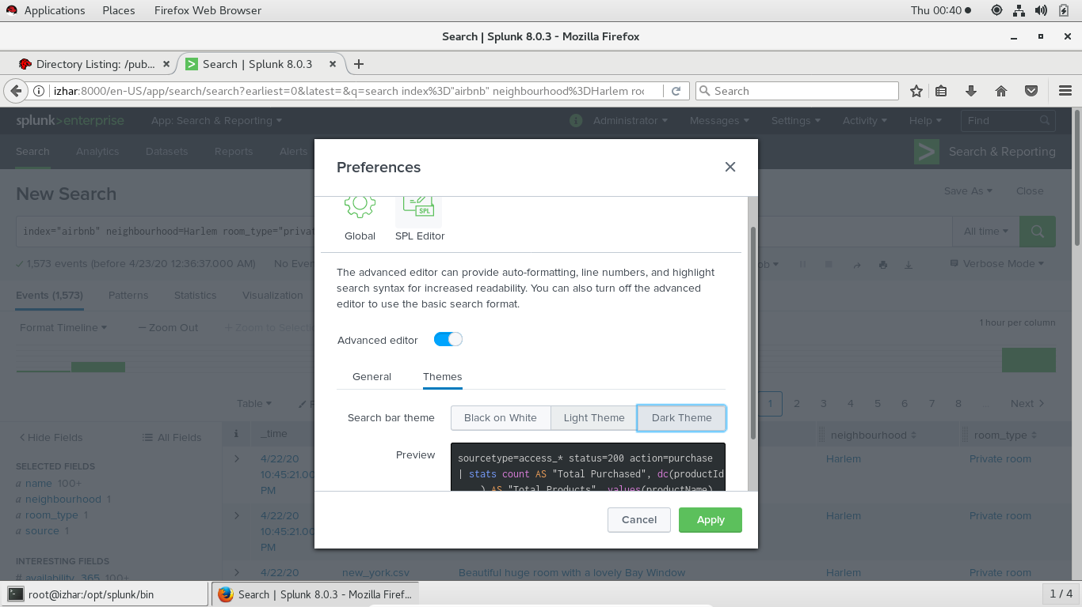
* SPL (SEARCH PROCESSING LANGAGE) 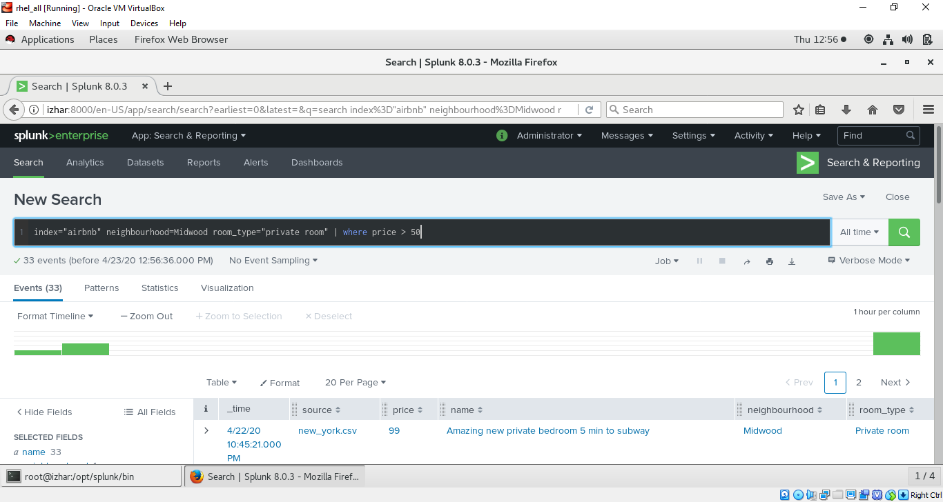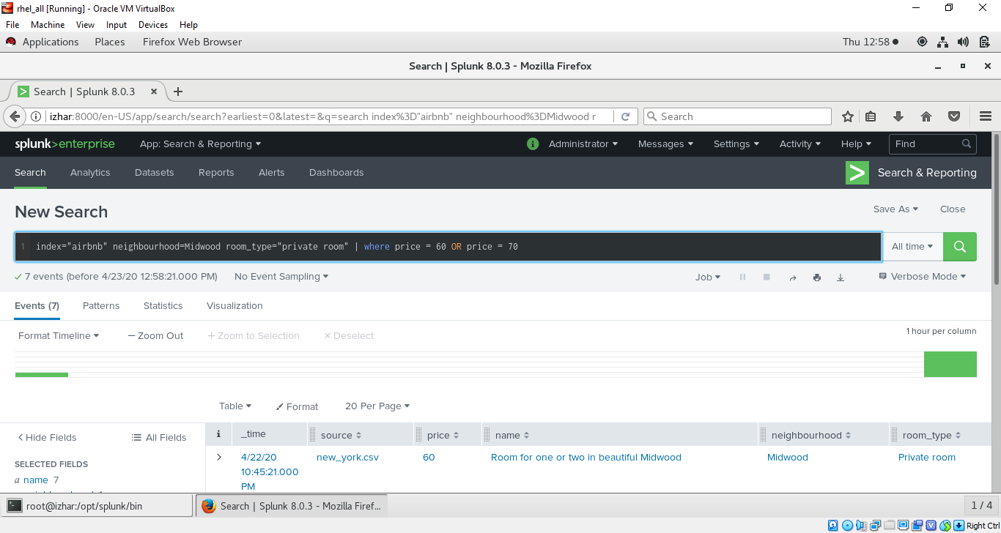
* USING SPL FILTERS AND MODIFING COMMANDS :- 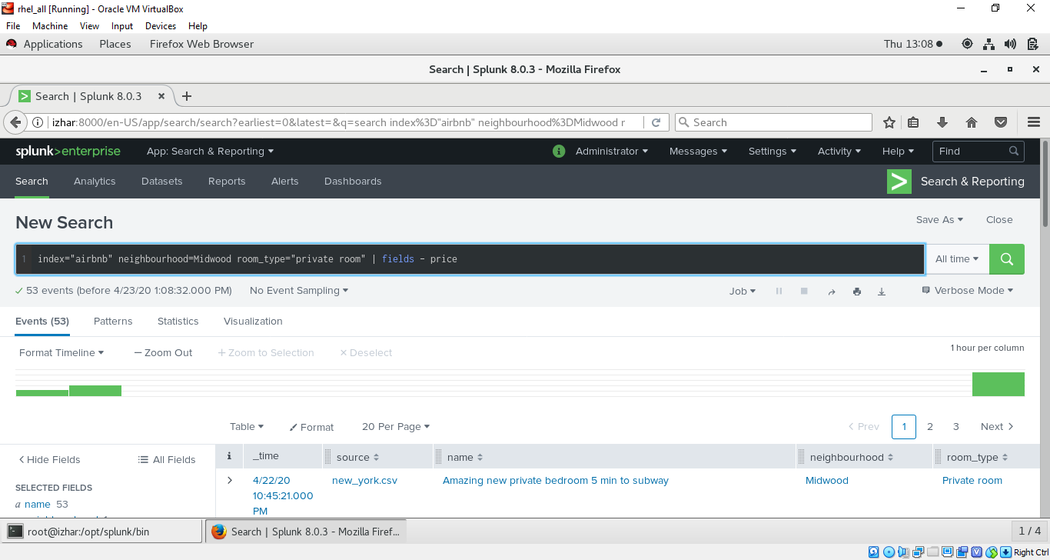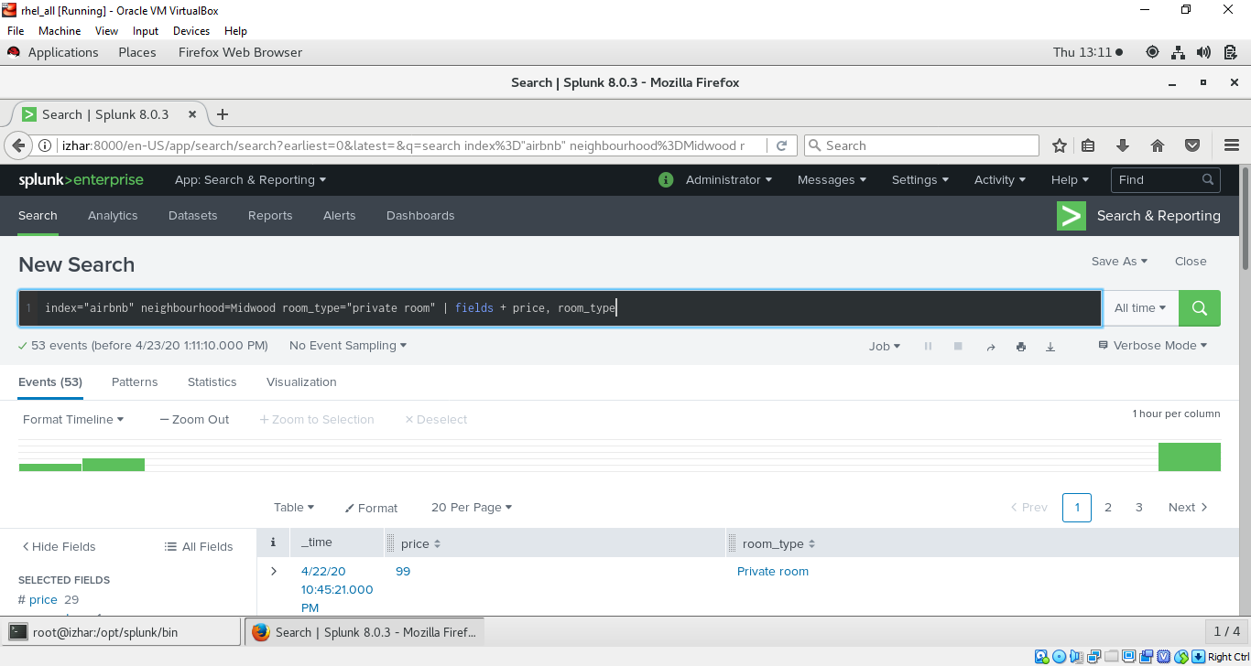

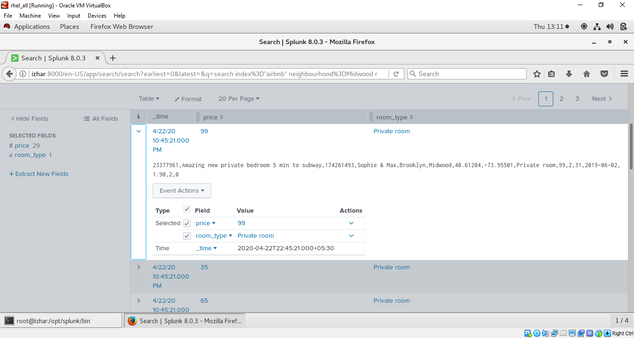

* SEARCHING RAW DATA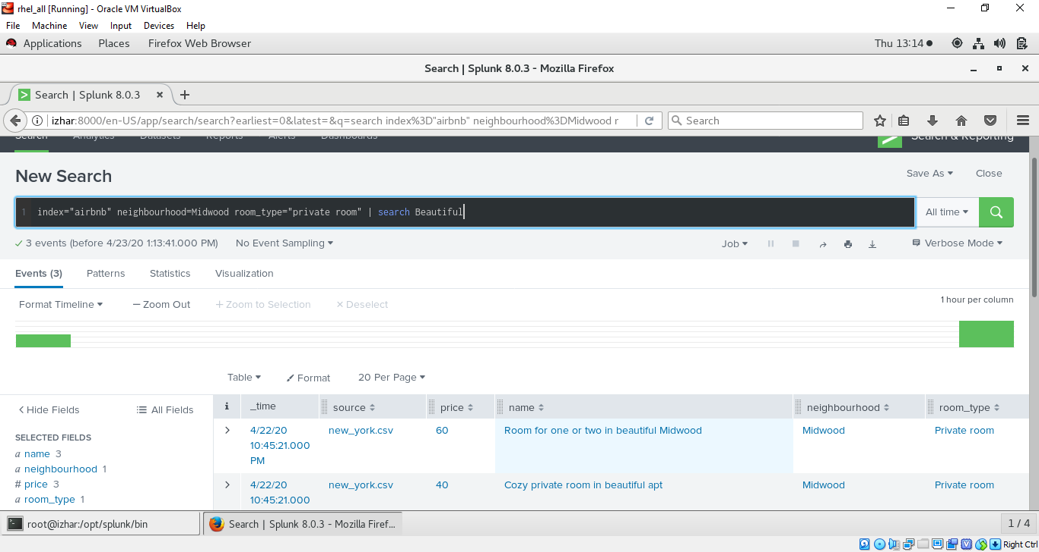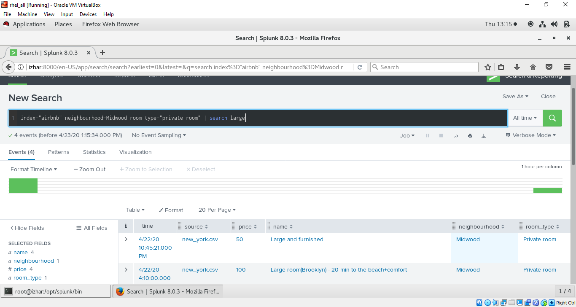
* RENAMING FIELDS (EX: PRICE AS COST)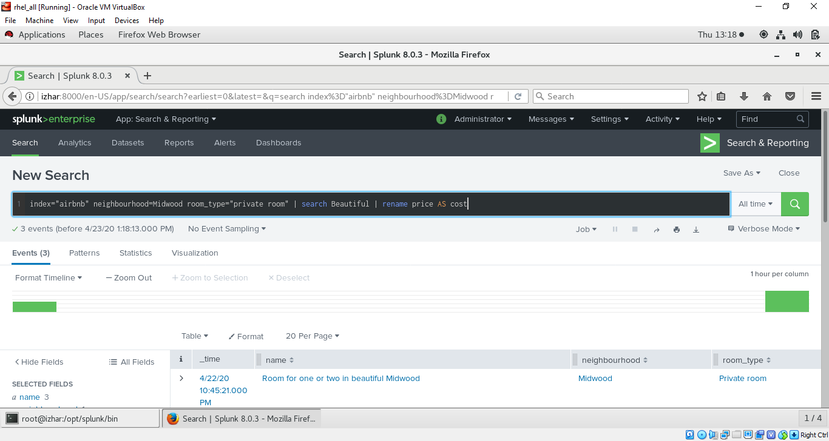 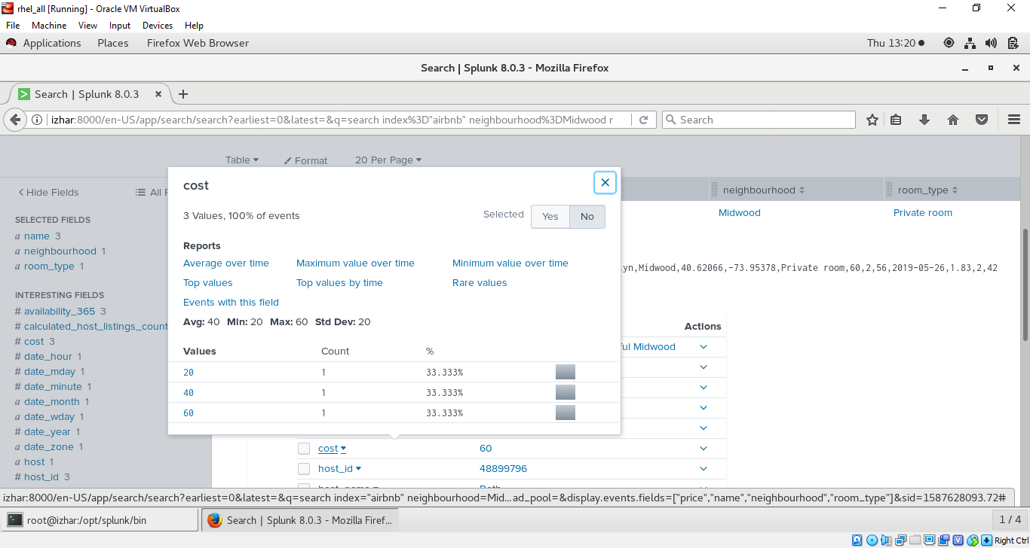
* DEDUP COMMAND :- 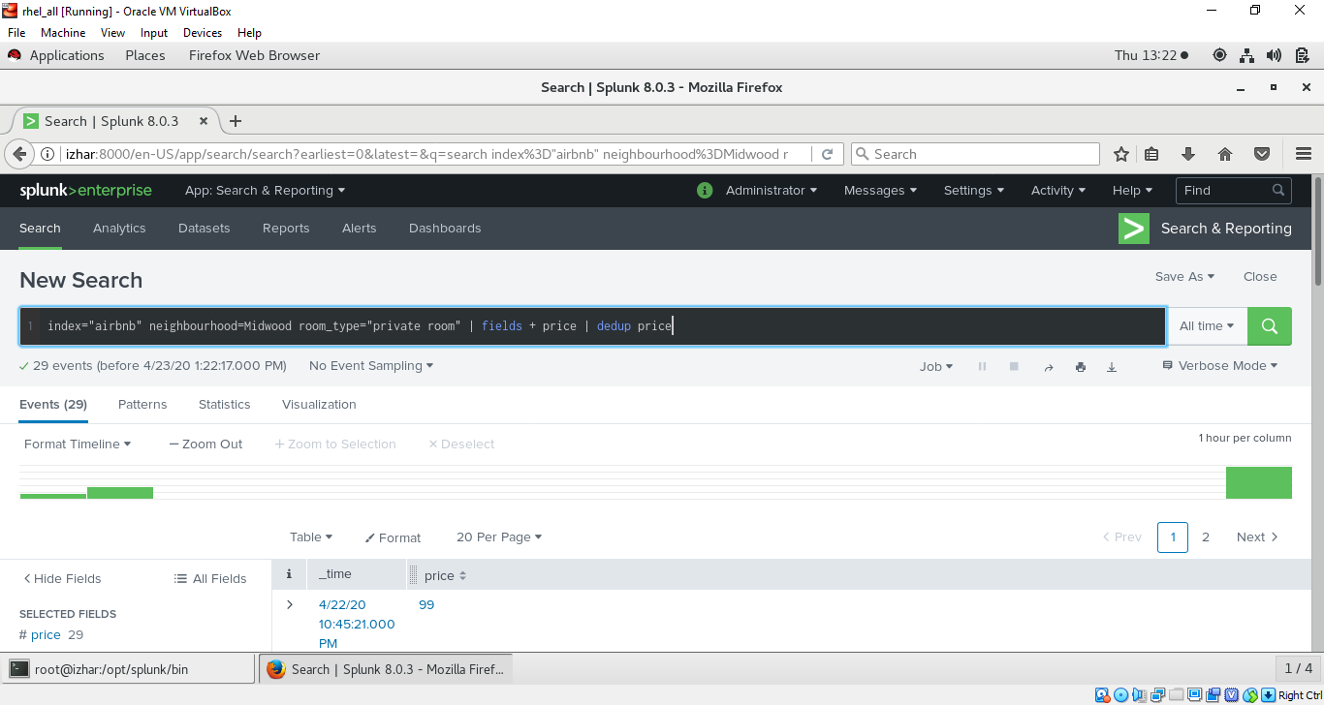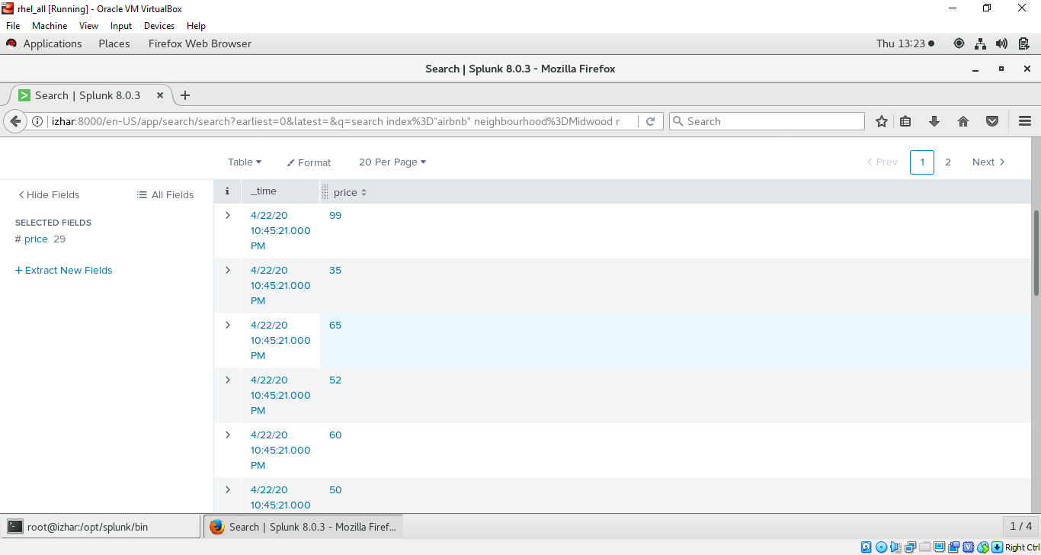
* ORDERING SEARCH RESULT :- TAIL CMD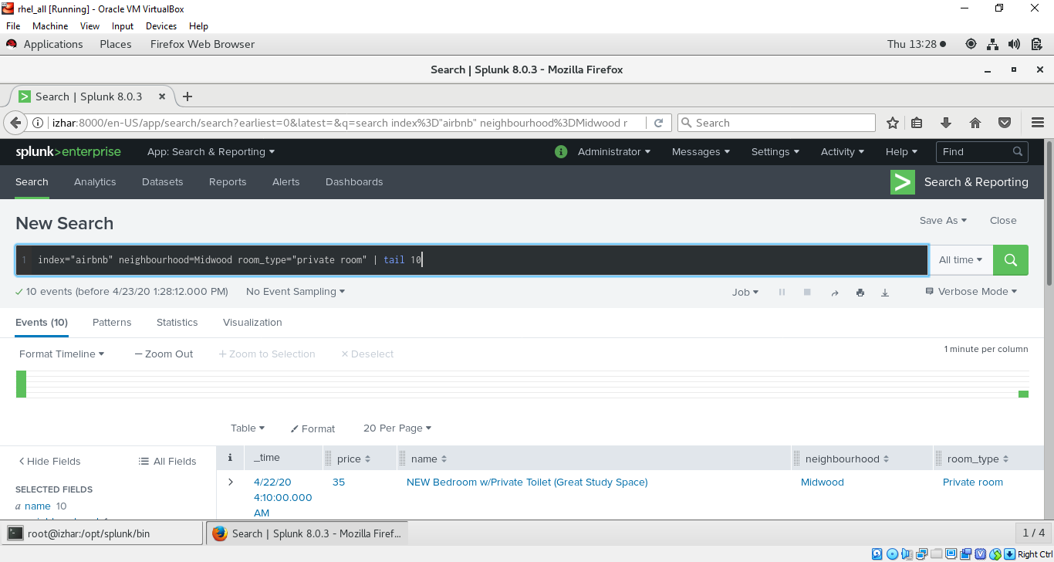
* HEAD CMD 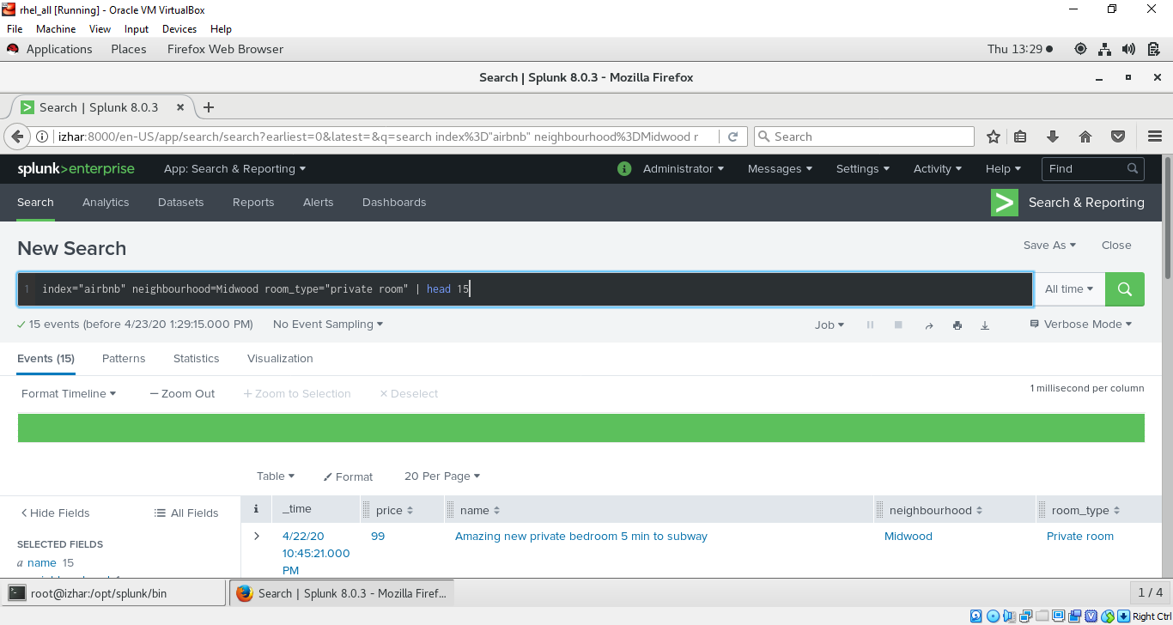
* SORT by specific field

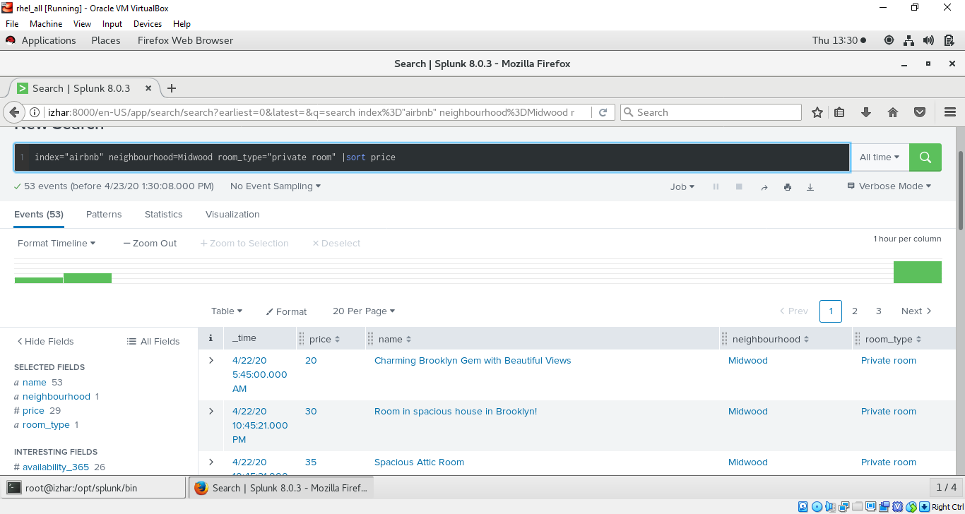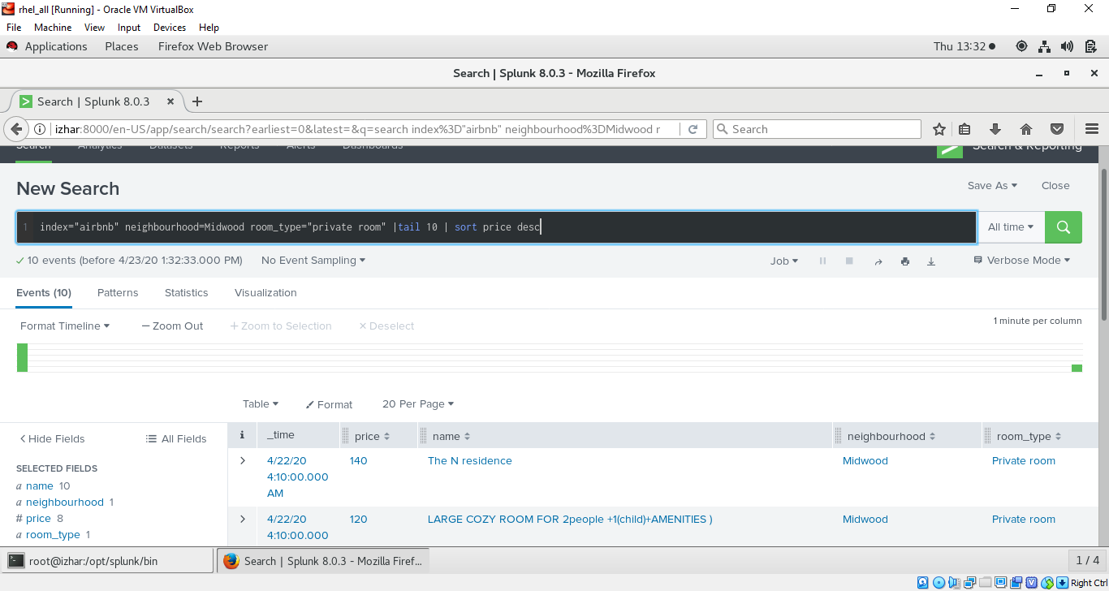

* TRANSFORMING COMMANDS (TOP, RARE, HIGHLIGHT, CONTINGENCY) :- 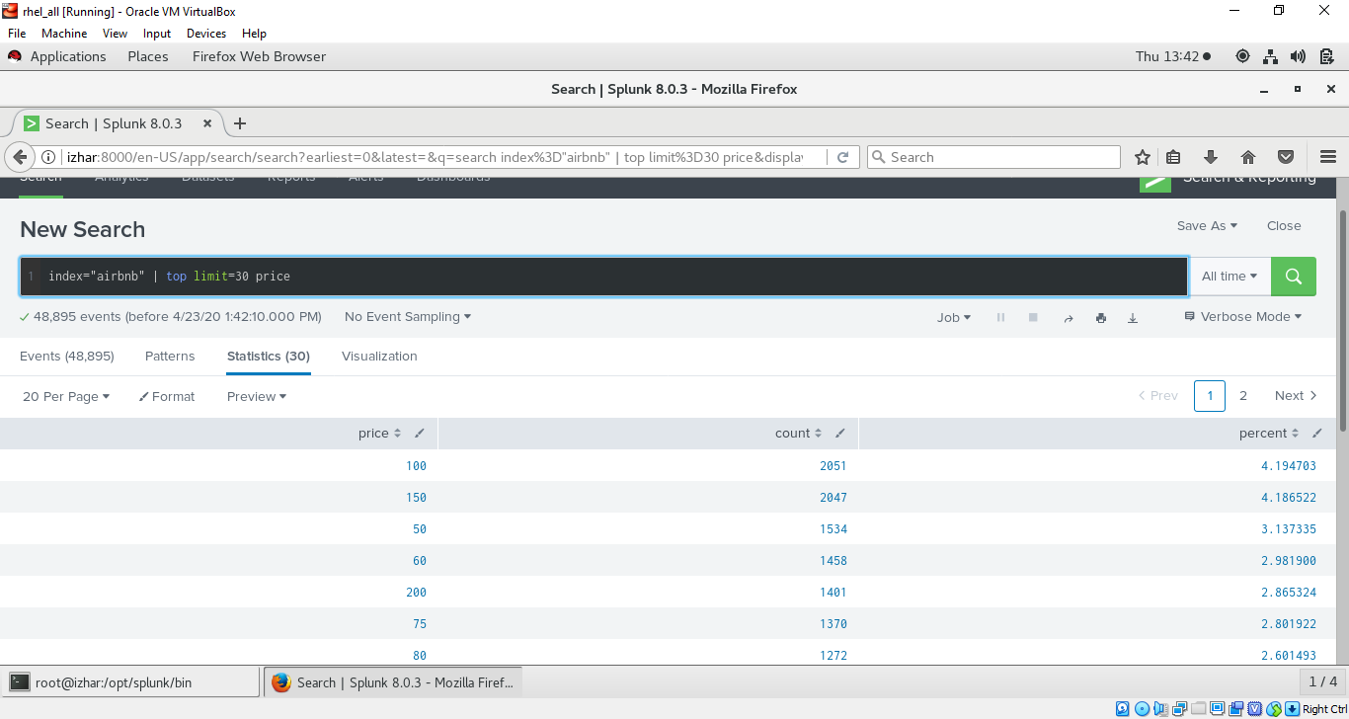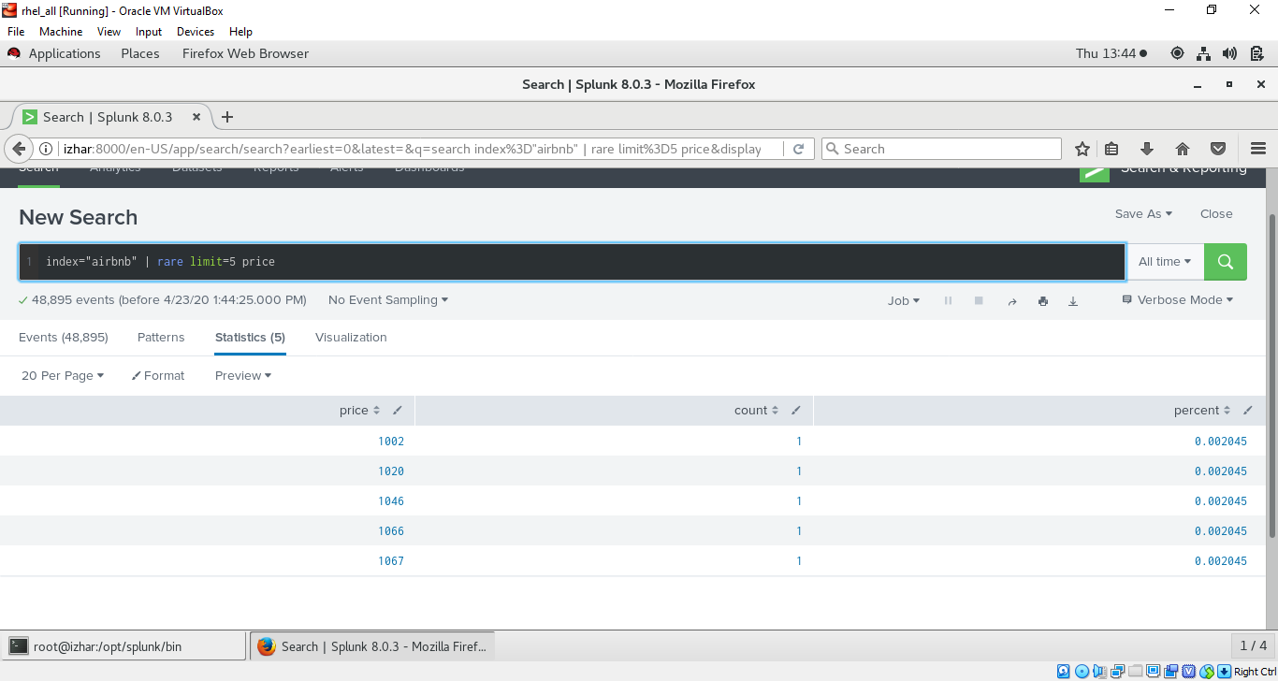
* CONTIGENCY CMD NEED TO SPECIFY TWO FIELDS 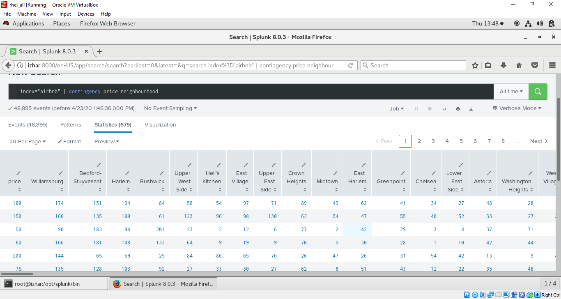
* STATS CMD :- 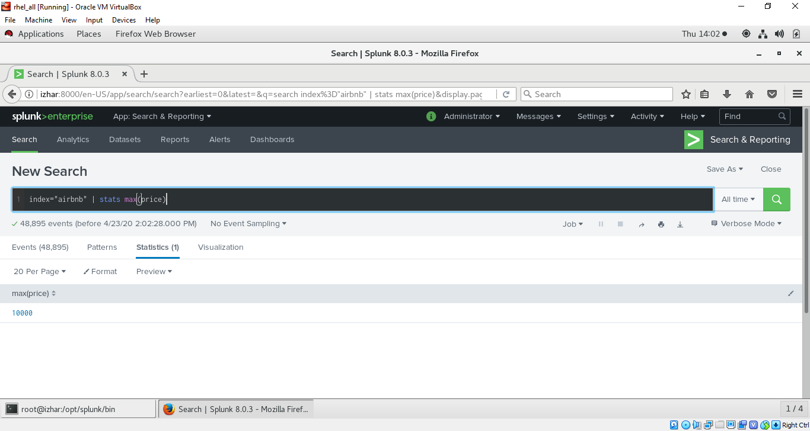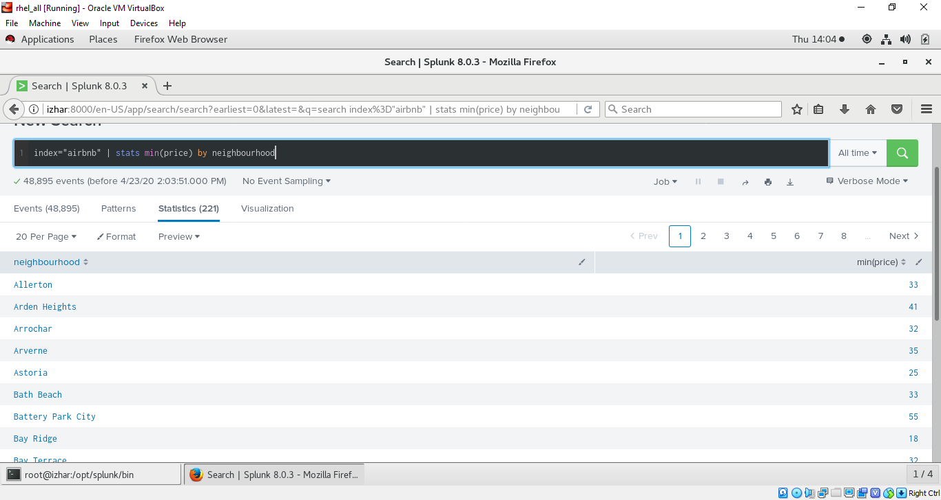

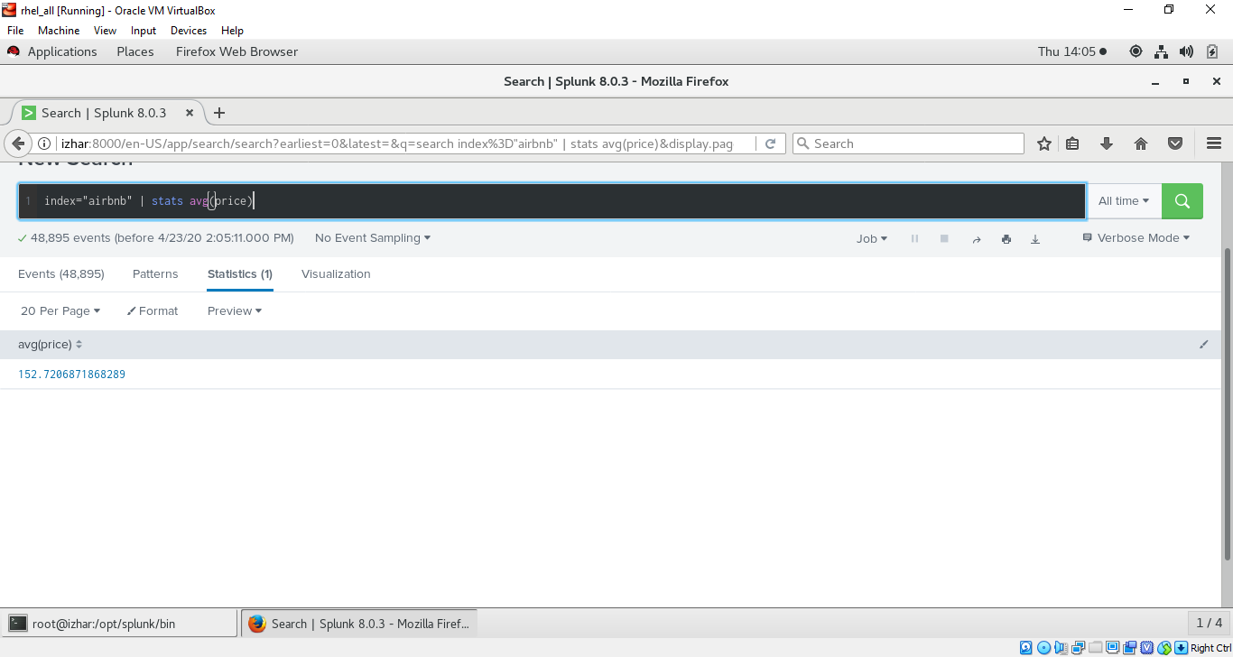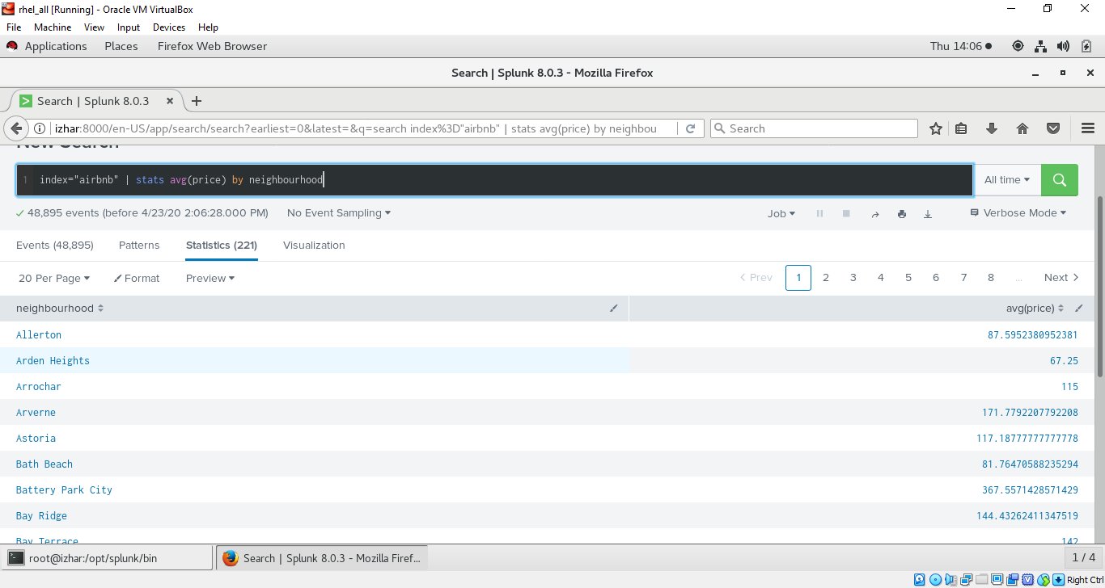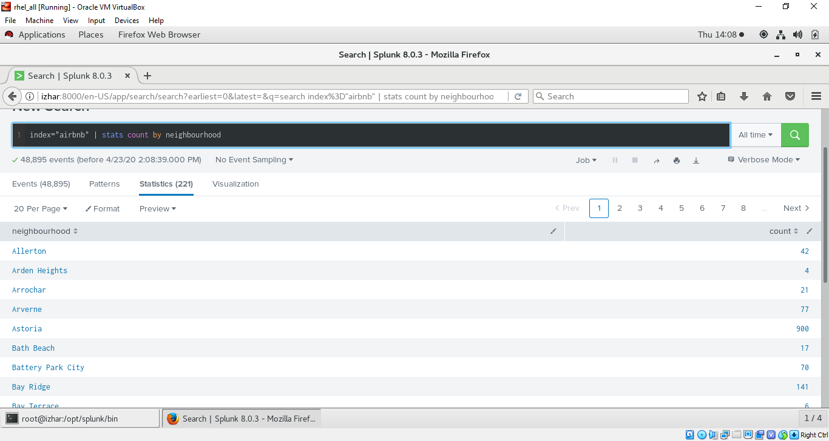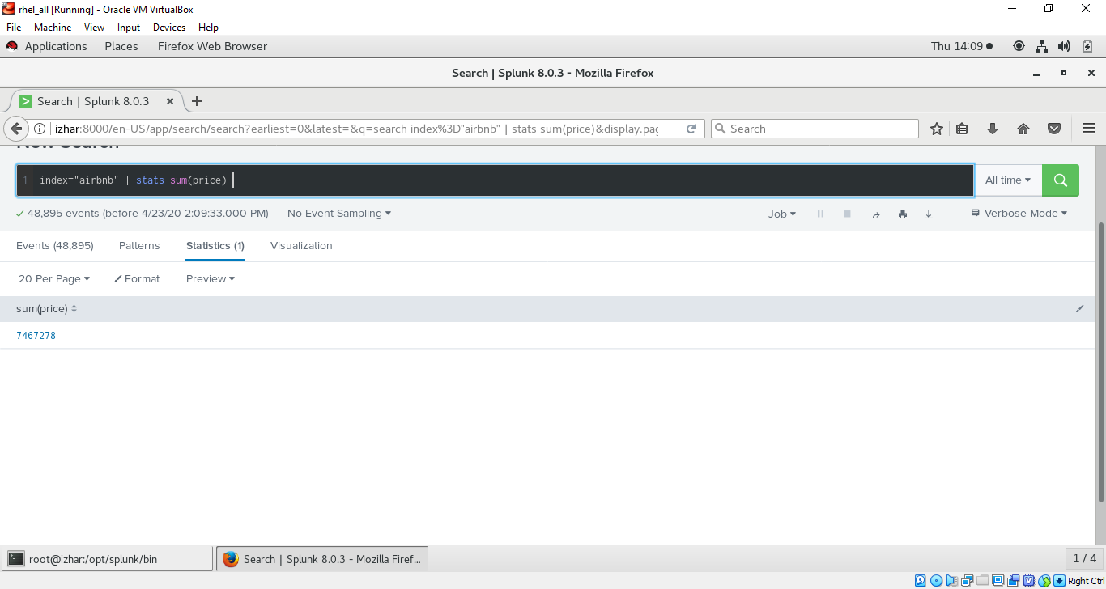

* CHART COMMANDS :- 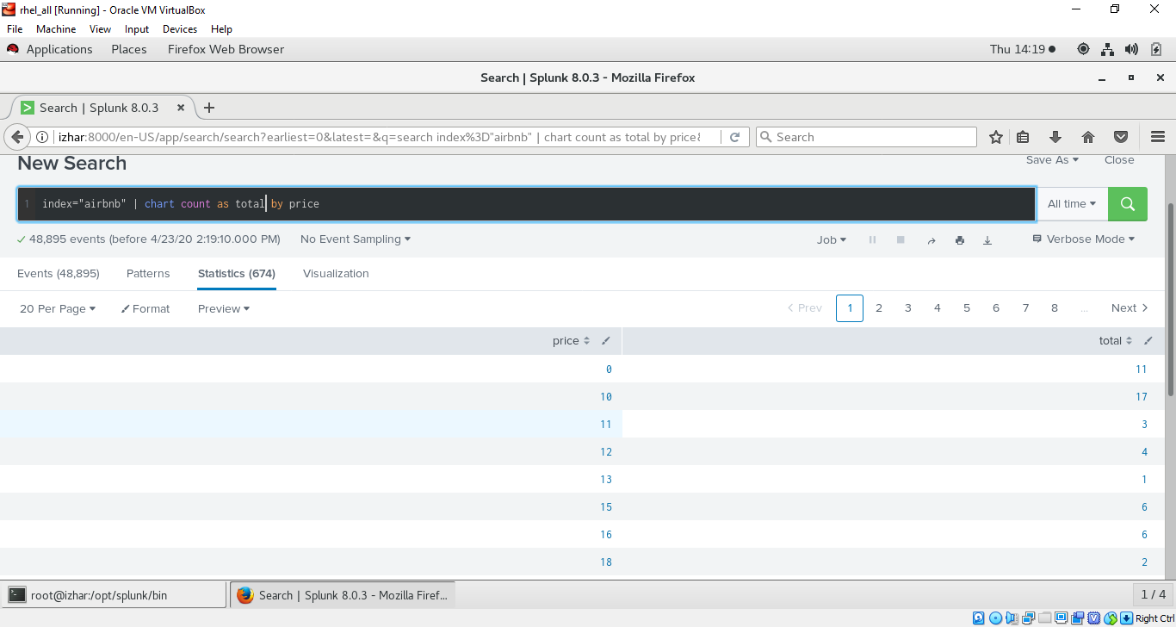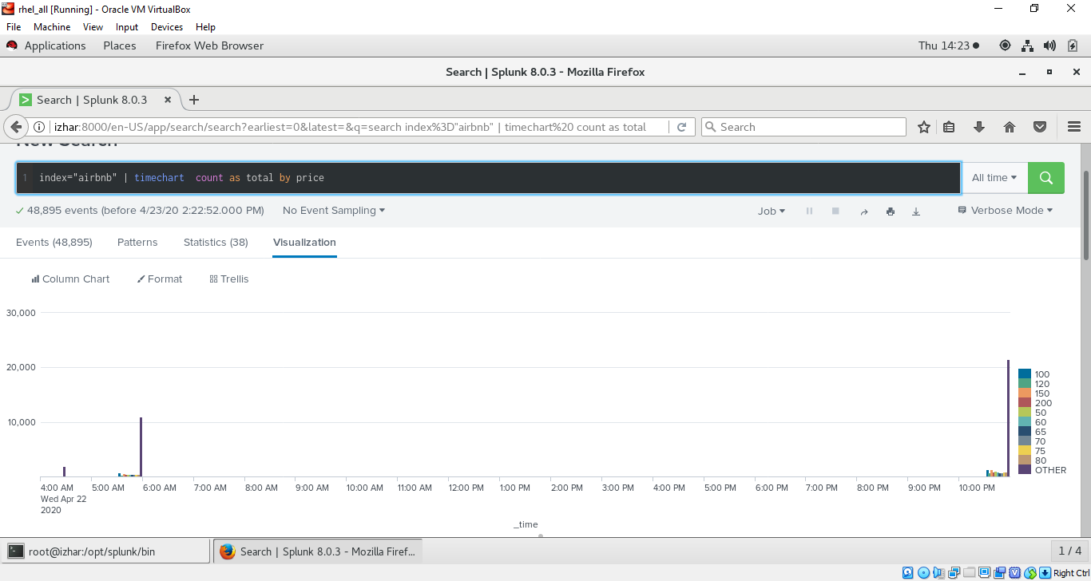
* BUILDING LOOKUP IN SPLUNK (USING TITANIC INDEX) :- GO TO SETTINGS -> SELECT LOOKUPS 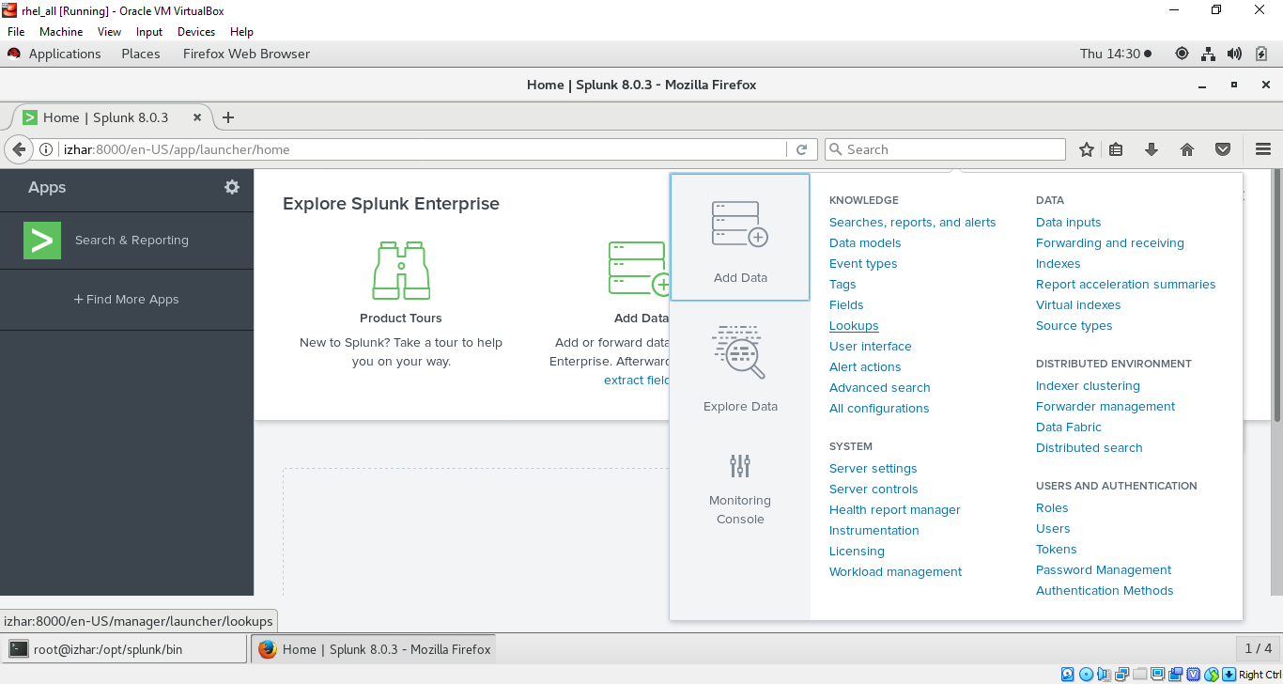
* CREATE A FILE WITH NAME (any) and make entries as below in file

Survived,Status

0,perished

1,survived

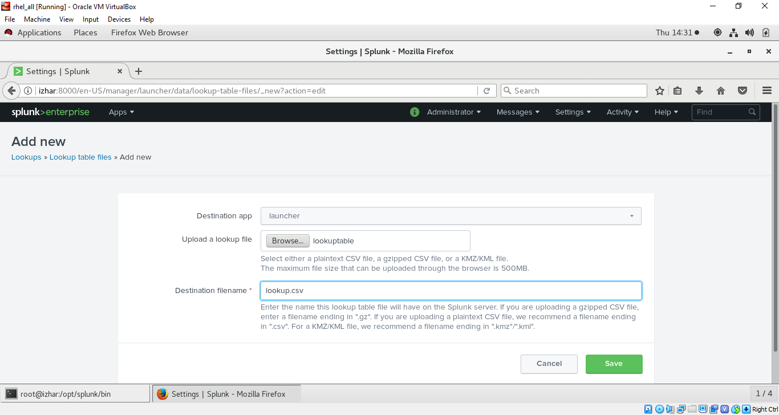

* CHANGING PERMISSIONS (PRIVATE -> GLOBAL , CLICK ON PERMISSIONS) 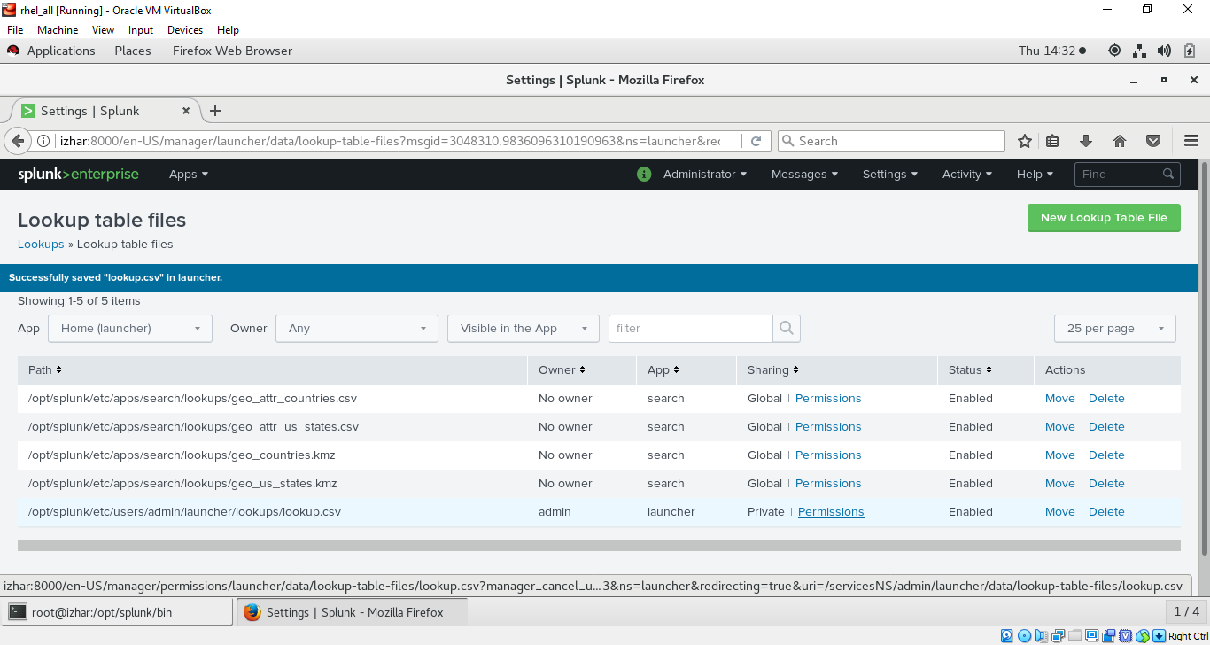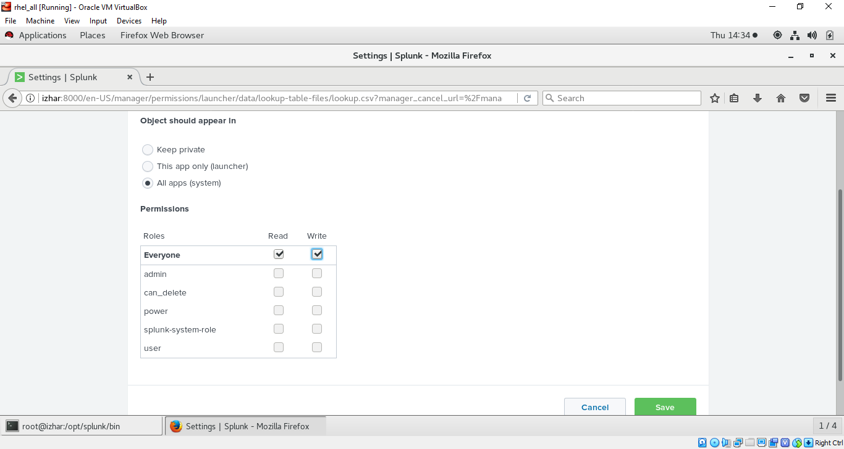
* NOW YOU WILL SEE PERMISSION SET TO GLOBAL

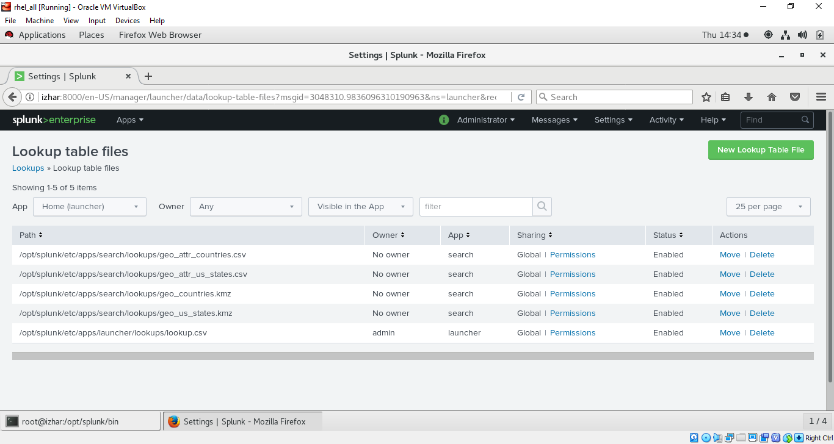

GO TO SEARCHING AND REPORTING TOOLS :-

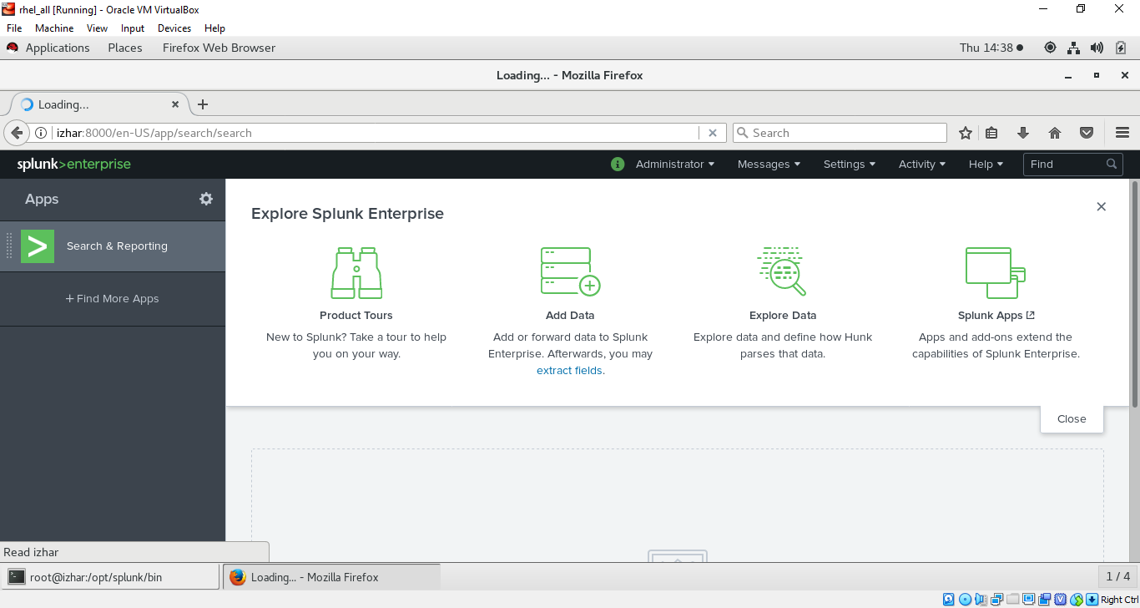

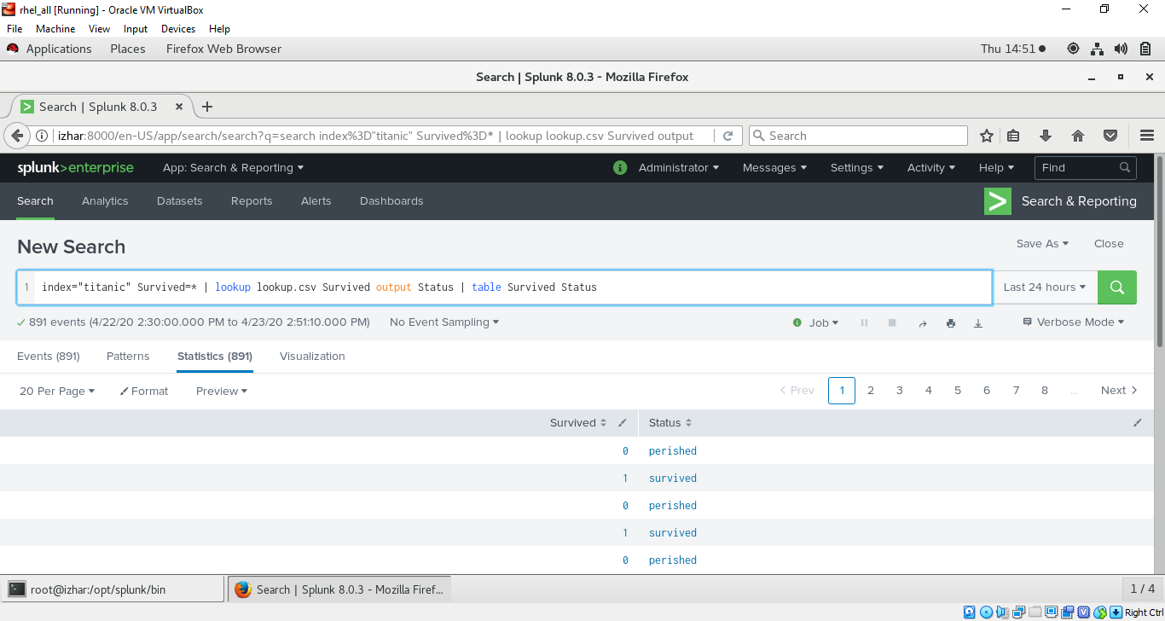

* specify the same column in search bar as in csv file you speacified matching the fields in your dataset